**GNSS Multipath Analysis and Processing Software (MAPS)**

**User Manual**

Written by Zhetao Zhang (zt.zhang@hotmail.com), Jingjing Yang, and Haijun Yuan (navyyuan@yeah.net)



**Research group of GNSS+ under**

**Complex Conditions (GCC)**

Dec 2024

**Contents**

1 Introduction 1

2 Mathematical model 1

2.1 Multipath analysis model 1

2.1.1 CMC method 1

2.1.2 GFix and IC method 1

2.1.3 GF and IC method 2

2.1.4 C/N0 template function 3

2.2 MHM model 4

2.2.1 Unified and differentiated MHM 4

2.2.2 MHM precision model 5

2.2.3 MHM refined by trend surface analysis 6

2.3 SF model 7

2.3.1 Traditional SF model 7

2.3.2 Window-matching SF model 7

3 Architecture of the MAPS 8

3.1 Module and function 8

3.2 Directory structure 9

4 How to Run the MAPS 13

4.1 MATLAB version 13

4.2 Input data 13

4.3 Multipath analysis 14

4.4 MHM modeling 16

4.5 SF modeling 18

5 Plotting function 20

5.1 Plotting of multipath analysis 20

5.1.1 CMC method 20

5.1.2 GFix and IC method 23

5.1.3 GF and IC method 23

5.1.4 C/N0 template function 24

5.2 Plotting of MHM modeling 24

5.2.1 2D sky plot 24

5.2.2 2D plane plot 27

5.2.3 3D sky plot 30

5.3 Plotting of SF modeling 31

6 Acknowledgement 33

7 Disclaimer 34

8 Contact us 34

Reference 34

# 1 Introduction

As one of the main error sources in Global Navigation Satellite Systems (GNSS) precise data processing, multipath effects are necessary to be analyzed and processed. An open-sourced GNSS multipath analysis and processing software (MAPS) is introduced and developed based on MATLAB 2021a. This user manual introduces the MAPS in detail, which is a multipath analysis and processing software for the multi-constellation and multiple-frequency GNSS observations including GPS, GLONASS, Galileo, and BDS. Using this software, one can easily analyze the multipath and build the corresponding models to process the multipath, such as multipath hemispherical map (MHM) models and sidereal filter (SF) models. Additionally, the MAPS also provides the diversity of plotting types to show the corresponding modeling results.

# 2 Mathematical model

## 2.1 Multipath analysis model

### 2.1.1 CMC method

The most widely used method for assessing the multipath effects is the code multipath combination (CMC) method (Zhang et al. 2021). This method requires at least two frequencies of phase observations, which can be expressed as (Leick et al. 2015)

${\overline{M}}_{r, i}^{ks}=P_{r, i}^{s}-\frac{f_{i}^{2}+f_{j}^{2}}{f_{i}^{2}-f_{j}^{2}}ϕ_{r, i}^{ks}+\frac{2f_{j}^{2}}{f_{i}^{2}-f_{j}^{2}}ϕ_{r, j}^{ks}+\frac{f_{i}^{2}+f_{j}^{2}}{f_{i}^{2}-f_{j}^{2}}λ_{i}N_{i}-\frac{2f_{j}^{2}}{f_{i}^{2}-f_{j}^{2}}λ_{j}N_{j}-ξ_{r, i}+ξ^{s,i}+ϵ_{{\overline{M}}_{r, i}^{ks}}$ (1)

where $s$ and $r$ denote the satellite and receiver, respectively. $i$ and $j$ denote the corresponding frequencies, $P$ and $ϕ$ denote the code and phase observations, respectively. $λ$ and $N$ denote the wavelength and ambiguity, respectively. $ξ$ and $ϵ$ denote the code hardware delay and observation noise, respectively. $\overline{M}$ denotes the equivalent code multipath consisting of the ambiguities of two frequencies, and receiver and satellite code hardware delays. Without cycle slips, the above error terms can be regarded as a constant during a certain period. Hence, the code multipath can be obtained as

$M_{r,i}^{s}={\overline{M}}_{r,i}^{s}-\frac{1}{n}\sum_{t=1}^{n}{\left[{\overline{M}}_{r,i}^{s}\left(t\right)\right]}$ (2)

where $n$ denotes the epoch number. The CMC method is widely used due to its high reliability. However, there are mainly two limitations. First, only the peak-to-peak behaviors of the code multipath can be estimated. Second, it can only work when there are two or more frequencies for a certain constellation.

### 2.1.2 GFix and IC method

In the geometry-fixed (GFix) and ionospheric-corrected (IC) method (Zhang et al. 2021), the observations need to be preprocessed. Specifically, the satellite clock errors should be corrected based on the broadcast or precise ephemeris. After the atmospheric delays are corrected, the code and phase observation equations can be deduced as

$P_{r, i}^{s}=ρ_{r}^{s}+δt_{r}+ξ_{r, i}+M_{r, i}^{s}+ϵ_{r, i}^{s}$ (3)

$ϕ_{r, i}^{s}=ρ_{r}^{s}+λ_{i}N_{r,i}^{s}+δt_{r}+ζ_{r, i}-ζ^{s,i}+ξ^{s,i}+m_{r, i}^{s}+ε_{r, i}^{s}$ (4)

where $δt_{r}$ and $ζ$ denote the receiver clock error and phase hardware delay, respectively. Since the receiver clock error and hardware delay need to be eliminated, the between-satellite single differencing is formed as

$P_{r, i}^{ks}=ρ_{r}^{ks}+M_{r, i}^{ks}+ϵ_{r, i}^{ks}$ (5)

$ϕ_{r, i}^{ks}=ρ_{r}^{ks}+λ_{i}N_{r,i}^{ks}-ζ^{ks,i}+ξ^{ks,i}+m_{r, i}^{ks}+ε_{r, i}^{ks}$ (6)

Based on the precise coordinates of the test station and satellites used, the GFix model is applied. When estimating the satellite coordinates, the broadcast or precise ephemeris can be used according to the demands of the users. Hence, the code multipath can be estimated as

$E\left[M_{r, i}^{ks}\right]=P_{r, i}^{ks}-ρ_{r}^{ks}$ (7)

where “ $E\left[∙\right]$” denotes the expectation operator. For the phase multipath, the bias term $b=λ_{i}N_{r,i}^{ks}-ζ^{ks,i}+ξ^{ks,i}$ can be treated as a constant when there are no cycle slips. Hence, the bias term can be removed by averaging over a certain period. Then, the phase multipath effects are estimated as

$E\left[m_{r, i}^{ks}\right]=ϕ_{r, i}^{ks}-ρ_{r}^{ks}-b$ (8)

with $b=\frac{1}{n}\sum_{t=1}^{n}{\left[ϕ_{r, i}^{ks}\left(t\right)-ρ_{r}^{ks}\left(t\right)\right]}$. The biggest advantage of the GFix and IC method is that it can still work even if there is only one observable satellite in addition to the reference satellite. However, its accuracy is highly dependent on the precision of the coordinates of the test station and used satellites. As usual, the accuracies of orbit and satellite clock are approximately 100 cm and 5 ns when using the broadcast ephemeris. However, for the precise ephemeris, these values can reach approximately 2.5 cm and 75 ps. Hence, it is better to apply the precise ephemeris. Besides, the multipath effects of the reference satellite are also included in the GFix and IC method.

### 2.1.3 GF and IC method

For the geometry-free (GF) and IC method (Zhang et al. 2021), the preprocessing is like that of the GFix and IC method. After preprocessing, the time-differenced operator is used. Then, the hardware delays and phase ambiguities can be regarded as eliminated in case of no cycle slips. The corresponding code and phase observations are deduced as

${∆P}_{r, i}^{s}=∆ρ_{r}^{s}+∆δt_{r}+∆M_{r, i}^{s}+{∆ϵ}_{r, i}^{s}$ (9)

${∆ϕ}_{r, i}^{s}={∆ρ}_{r}^{s}+∆δt_{r}+{∆m}_{r, i}^{s}+∆ε_{r, i}^{s}$ (10)

where “ $∆$” denotes the time-differenced operator. Since the above observation models are rank deficient, the parameters need to be combined as

${∆P}_{r, i}^{s}=∆{\tilde{ρ}}_{r}^{s}+∆M_{r, i}^{s}+{∆ϵ}_{r, i}^{s}$ (11)

${∆ϕ}_{r, i}^{s}=∆{\tilde{ρ}}_{r}^{s}+∆{\tilde{ε}}_{r, i}^{s}$ (12)

with $∆{\tilde{ρ}}_{r}^{s}=∆ρ_{r}^{s}+∆δt_{r}$, $∆{\tilde{ε}}_{r, i}^{s}={∆m}_{r, i}^{s}+∆ε_{r, i}^{s}$. Then, the time-differenced code multipath effects can be estimated as

$E\left[∆M_{r, i}^{s}\right]={∆P}_{r, i}^{s}-{∆ϕ}_{r, i}^{s}$ (13)

This method is also convenient and can work under any conditions, but the method also has some limitations. First, only the time-differenced code multipath effects can be depicted, where the undifferenced multipath is missing. Second, the phase multipath effects cannot be obtained.

### 2.1.4 C/N0 template function

The modeling procedure of the carrier-to-noise density ratio (C/N0) template function mainly includes the following four steps (Strode and Groves 2015; Zhang et al. 2019). The first step is the consistency checking. Since the C/N0 is influenced by the power output of the satellite transmitter, one needs to check whether the observed C/N0 from different satellites are significantly discrepant. Since the C/N0 template observations can be treated to be normally distributed, a threshold of 3-sigma is applied (Koch 1999). Specifically, the observed C/N0 of one certain satellite $s$ should be classified if

$\left|\overline{{\text{C/N0}}_{s}}-\overline{\text{C/N0}}\right|≥3σ_{\text{C/N0}}$ (14)

where $\overline{{\text{C/N0}}_{s}}$ denotes the mean value of C/N0 for the certain satellite $s$; $\overline{\text{C/N0}}$ denotes the mean value of C/N0 for all the satellites classified in the same group; $σ_{\text{C/N0}}$ denotes the corresponding standard deviation (STD).

The second step is to check the minimum sample size of C/N0 template observations. It is noted that if the number of template dataset is too few, the accuracy of the C/N0 template function is limited. Because the C/N0 template observations are independent and normally distributed in each elevation interval (e.g., 0.1 degrees), the minimum sample size $n_{\text{min}}$ can be estimated as (Lehmann and Romano 2006)

$n_{\text{min}}≥Z_{1-α/2}^{2}\frac{σ^{2}}{ε^{2}}$ (15)

where $Z_{1-α/2}$ denotes the quantile of standard normal distribution with a significance level of $α$; $σ$ and $ε$ denote the STD and absolute error, respectively. In general, we can assume that $α=0.05$ (i.e., $Z_{1-α/2}=1.96$) and $σ=3ε$, thus causing $n_{\text{min}}=35$ for each 0.1-degree interval. Hence, we apply $n_{\text{min}}=350$ for each 1-degree elevation interval.

Then, if the number of C/N0 observations is larger than the $n_{\text{min}}$ in each elevation interval, the raw template dataset can be refined. Specifically, the C/N0 observations will be deleted if their values exceed three or two times of their STDs in each elevation interval. This step is iterative until the appropriate threshold is determined as

$∀θ, ∃n\left(κα\right)≥n_{\text{min}}$ (16)

where $κ$ denotes the threshold to be determined; $n\left(κα\right)$ denotes the numbers of C/N0 within $κα$.

Finally, the C/N0 template observations and the corresponding STDs can be fit using the elevation-dependent functions (e.g., the third-order polynomials). It is worth noting that these template functions usually only need to be determined once in advance unless the signal strength is changed by the official government.

## 2.2 MHM model

### 2.2.1 Unified and differentiated MHM

For MHM modeling, the double-differenced (DD) residuals, single-differenced (SD) residuals, and un-differenced (UD) residuals can be used (Zhang et al. 2023). However, since the MHM is established according to one satellite, it is recommended to conduct the transformation of residuals. That is, one needs to convert the DD residuals into SD residuals between the receivers by

$\left[\begin{matrix}{\hat{P}}_{DD} \\ {\hat{Φ}}_{DD}\end{matrix}\right]=B∙\left[\begin{matrix}{\hat{P}}_{SD} \\ {\hat{Φ}}_{SD}\end{matrix}\right]$ (17)

where ${\hat{P}}_{SD}$ and ${\hat{Φ}}_{SD}$ denote the code and phase SD residual samples, respectively. Due to the rank deficient of design matrix $B$ caused by the existence of the reference satellite,one cannot directly obtain the SD residual samples based on Eq. (17). Hence, the implementation of an additional constraint is required, albeit with the possibility of introducing additional bias. In this study, a commonly used zero-mean constraint based on elevation was adopted as

$\left\{\begin{aligned}\sum_{i=1}^{s}{ϖ{\hat{P}}_{DD}^{i}}=0 \\ \sum_{i=1}^{s}{ϖ{\hat{Φ}}_{DD}^{i}}=0\end{aligned}\right.$ (18)

where ${\hat{P}}_{DD}^{i}$ and ${\hat{Φ}}_{DD}^{i}$ denote the $i$-th DD samples of ${\hat{P}}_{DD}$ and ${\hat{Φ}}_{DD}$, respectively. $ϖ$ denotes the elevation-dependent weighting scheme. It is worth noting that the zero-mean assumption in MHM is not completely strict because the difference in satellite constellation distribution may affect the zero-mean reference. To address this issue, more strict strategies can be employed, such as incorporating random walk constraints or multi-point hemispherical grids. However, for practical reasons, a quality control strategy is widely adopted. Specifically, only the satellites with a certain high elevation (e.g., *β*) are selected as reference satellites in the acquisition of DD samples, thereby minimizing the potential bias associated with the zero-mean assumption.

The modeling procedure of traditional MHM model is mainly divided into three steps, which are as follows:

1. According to the satellite azimuth and elevation and the desired grid resolution, the residuals are divided into different grids.
2. Quality control strategies are conducted in each grid to eliminate the outliers of residual samples. Assuming the residuals are normally distributed, the samples that exceed twice the STD are excluded. Besides, only when the number of remaining samples is greater than a certain value, the estimated multipath correction in this grid is regarded as valid. In this study, the minimum sample size ${num}_{min}$ can be determined as

${num}_{min}≥Z_{1-α/2}^{2}{\left(\frac{STD}{E}\right)}^{2}$ (19)

where $STD$ denotes the standard deviation of absolute error $E$. The absolute error $E$ denotes the difference between the multipath correction and the corresponding reference value in this grid. Without loss of generality, the value of $α$ is set to 5%, and the ratio between $STD$ and $E$ is set to 2. Consequently, ${num}_{min}$ in each grid is 16 in this study.

1. Finally, according to the mean values of remaining residual samples in each grid, high-precision and high-reliability MHM can be modeled according to a specific criterion. That is, one can construct a unified MHM model regardless of the observation type. Also, differentiated MHM models can be established according to the orbit and frequency types of satellites (i.e., SMHM and FMHM) (Zhang et al. 2023).

### 2.2.2 MHM precision model

For the MHM precision (PMHM) model (Zhang et al. 2024), the mean standard deviation (MSTD) is adopted as the grid value. In multipath modeling, the mean value of residuals in each grid is regarded as the multipath correction of this grid. Because all residual samples contain errors, the mean value will also contain errors. The MSTD can express the accuracy of the mean value of a sample set. The traditional STD reflects the degree of dispersion for a sample set in a grid. While the MSTD reflects the reliability of the obtained mean value of this grid. Here, the mean value of samples is applied as the multipath correction. Therefore, compared to the traditional STD, the MSTD can better reveal whether the multipath correction is reliable.

The MSTD $S$ for a certain elevation and azimuth grid in the MHM precision model can be defined as

$S=\frac{\sqrt{\frac{\sum_{i=1}^{n}{{\left(y_{i}-\overline{y}\right)}^{2}}}{n-1}}}{\sqrt{n}}$ (20)

where $\overline{y}$ denotes the mean value of a certain grid in the MHM model (i.e., multipath correction); $y_{i}$ denotes the multipath correction sample of index $i\left(i=1,2,…,n\right)$ with $n$ denoting the number of multipath correction samples in the grid.

### 2.2.3 MHM refined by trend surface analysis

For the MHM refined by trend surface analysis (T-MHM) (Wang et al. 2019; Lu et al. 2021; Yuan et al. 2024), the station sky is divided into azimuth and elevation grids. Then, T-MHM performs trend surface analysis to fit the multipath variations inside each grid, which can be expressed as

$m_{i}\left(a_{i}, e_{i}\right)={\hat{m}}_{i}\left(a_{i}, e_{i}\right)+ϵ_{i}$ (21)

where $i = 1, 2, …, n$ denotes the sample index in a certain grid. $\left(a_{i}, e_{i}\right)$ denote the coordinates of the residual sample in the grid determined by the azimuth and elevation. $m_{i}$ and ${\hat{m}}_{i}$ denote the multipath observations and multipath estimates, respectively. $ϵ_{i}$ denotes the unfitted residual within the grid.

The mathematical equations used to calculate the trend surface include polynomial functions and Fourier series. Usually, T-MHM utilizes the commonly used polynomial functions, which are expressed as

${\hat{m}}_{i}\left(a_{i}, e_{i}\right)=b_{0}+b_{1}a_{i}+b_{2}e_{i}$ (22)

where $b_{0}$, $b_{1}$, and $b_{2}$ denote the polynomial coefficients. Let $a_{i}=N_{1i}$, $e_{i}=N_{2i}$. The general formula of the trend surface can be written as

${\hat{m}}_{i}=b_{0}+b_{1}N_{1i}+b_{2}N_{2i}$ (23)

Then, the least squares normal equations can be expressed as

$\left(N^{\text{T}}N\right)B=N^{\text{T}}M$ (24)

where $N=\left[\begin{matrix}1 & N_{11} & N_{21} \\ 1 & N_{12} & N_{22} \\ ⋮ & ⋮ & ⋮ \\ 1 & N_{1n} & N_{2n}\end{matrix}\right]$, $M=\left[\begin{matrix}m_{1} \\ m_{2} \\ ⋯ \\ m_{n}\end{matrix}\right]$ and $B=\left[\begin{matrix}b_{0} \\ b_{1} \\ b_{2}\end{matrix}\right]$. Then, the polynomial coefficients of the trend surface can be estimated as

$\hat{B}={\left(N^{\text{T}}N\right)}^{-1}N^{\text{T}}M$ (25)

It is noted that the linear, quadratic, and cubic trend surfaces can be reasonably choose in practical applications. To avoid under-fitting and over-fitting of multipath variation within grids, some statistic criteria can be utilized, such as the goodness-of-fit test and significance test (Sobol 1991; Cornell 1987; Anscombe 1973). When the statistical tests are failed, the mean value of residuals can be adopted as the multipath correction in this grid.

## 2.3 SF model

### 2.3.1 Traditional SF model

The modeling procedure of traditional SF model is mainly divided into the following three steps (Bock et al. 2000):

1. According to the daily broadcast ephemeris, the satellite orbit repetition period is calculated at each epoch. The formula for calculating the satellite orbit repetition period using Kepler's third law is

$t_{s}=\frac{\text{2}kπ}{\sqrt{GM}a^{-\frac{3}{2}}+∆n}$ (26)

where $t_{s}$ denotes the satellite orbit repetition period. $k$ denotes the number of satellite revolutions. $\sqrt{GM}$ denotes the standard gravity parameter. $a$ denotes the semi-major axis of satellite orbit. $∆n$ denotes the correction for the satellite angular velocity.

1. Allocate the residuals for different satellites at each epoch and conduct the wavelet filtering on the residuals at each epoch to mitigate the noise.
2. Finally, the advanced satellite period at the current epoch is obtained by using the broadcast ephemeris. Then, the corresponding residual of a cycle of the satellite is used as a correction to correct the multipath at the current epoch. That is, a model for real-time multipath correction of each satellite can be constructed based on the residuals of different satellites at different epochs.

### 2.3.2 Window-matching SF model

For the traditional SF model, the core is to find the satellite orbital period based on the broadcast ephemeris. Then, the window-matching SF (abbreviated as SF_W) model is proposed based on the correlation of residuals. The modeling procedure of SF_W model is mainly divided into the following three steps:

1. According to the obtained residuals, it is necessary to first determine the number of epochs contained in each window, i.e., the size of the window.
2. Then, a cross-correlation method (CCM) is used to find the window with the highest correlation coefficient between the current window and the window in the residuals obtained in advance. The CCM is a common method to obtain multipath repeat time (Ragheb et al. [2007](https://link.springer.com/article/10.1007/s40328-022-00384-6#ref-CR21)), which determines the repeat time according to the correlation coefficient after staggering the different epochs between two residual series. The correlation coefficient is defined as

$ρ_{XY}=\frac{Cov\left(X,Y\right)}{\sqrt{D\left(X\right)}\sqrt{D\left(Y\right)}}$ (27)

$Cov\left(X,Y\right)=\frac{1}{n}\sum_{n}^{1}{(x_{i}-μ_{x})(y_{j}-μ_{y})}$ (28)

where $X$ denotes the current residual series and $Y$ denotes the obtained residual series in advance with the same size as $X$. $Cov\left(X,Y\right)$ denotes the covariance of $X$ and $Y$. $D\left(X\right)$ and $D\left(Y\right)$ denote the variance of $X$ and $Y$, respectively. When the value of $ρ_{XY}$ is the maximum, the staggered epoch is the sidereal shift.

1. According to the residual series of the two best matching windows, a multipath solution based on least squares is performed. Specifically, the satellite SD residuals are divided into the certain segments such as segment Ⅰ and segment Ⅱ. At the same time, segment Ⅱ overlaps with the previous segment Ⅰ to ensure a near real-time performance. The CCM is used to calculate the multipath repeat time of different segments. Then, for the $i$-th epoch on current residual series, the template window is formed by several epochs as

$x_{2}\left(t_{i-l}\right),⋯,x_{2}\left(t_{i-1}\right),x_{2}\left(t_{i}\right),x_{2}\left(t_{i+1}\right),⋯,x_{2}\left(t_{i+l}\right)$ (29)

where $i$ denotes the epoch index and the window size is the number of epochs. The matched window is determined by the repeat time obtained by the CCM.

1. Assuming that both the template window and matched window have been obtained, the following affine transformation model (Shen et al. [2020](https://link.springer.com/article/10.1007/s40328-022-00384-6#ref-CR25)) is applied to determine the value of multipath correction of the $i$-th epoch as

$\left[\begin{matrix}\begin{matrix}x_{2}\left(t-l\right) \\ ⋮\end{matrix} \\ x_{2}\left(t\right) \\ \begin{matrix}⋮ \\ x_{2}\left(t+l\right)\end{matrix}\end{matrix}\right]=\left[\begin{matrix}\begin{matrix}x_{1}\left(t-l\right) \\ ⋮\end{matrix} & \begin{matrix}1 \\ ⋮\end{matrix} \\ x_{1}\left(t\right) & 1 \\ \begin{matrix}⋮ \\ x_{1}\left(t+l\right)\end{matrix} & \begin{matrix}⋮ \\ 1\end{matrix}\end{matrix}\right]\left[\begin{matrix}a \\ b\end{matrix}\right]+ε$ (30)

where $a$ and $b$ denote the scaling factor and translation factor, respectively. $ε$ denotes the random noise. The parameters $a$ and $b$ can be estimated by the least square method. The weight matrix is determined according to the distance between the epochs. The closer to the $i$-th epoch, the greater the weight of sample.

In conclusion, the SF_W model can construct a real-time multipath correction for each satellite based on the residuals of different satellites at different epochs, which is also superior to the traditional SF model in terms of stability.

# 3 Architecture of the MAPS

## 3.1 Module and function

The MAPS integrates two core modules including the multipath analysis module and multipath processing module, and the flowchart of MAPS is shown in Fig. 1.

**Fig. 1** Flowchart of the MAPS

Specifically, the multipath analysis module includes three multipath estimation methods: the CMC method, the GFix and IC method, and the GF and IC method. The above methods can accurately estimate and analyze the multipath even in the challenging environments, which is beneficial to GNSS multipath processing and the improvement of accuracy and reliability of PNT applications. The results of estimated multipath can also be plotted, and the plotting types include time series plot and sky plot. In addition, the multipath analysis module supports the establishment of C/N0 template function, which is important to accurately depict and detect the multipath in the challenging environments. In this part, the “XXX.ddres” file will be read, which contains the elevation and C/N0 values of satellites. Then, the C/N0 template function modeling and plotting are carried out.

In the multipath processing module, five types of MHM models are supported including the traditional MHM, PMHM, SMHM, FMHM, and TMHM models. For these models, it is necessary to read the residual files. There are three types of residual forms used in MHM modeling, including double differenced residual (DDRES), undifferenced and ionospheric-free residual (UDIFRES), and undifferenced and uncombined residual (UDUCRES). In addition, two types of SF models are supported in the multipath processing module including the traditional SF model and the window matching SF (SF_W) model. In conclusion, the MAPS can efficiently analyze and process the multipath for multiple GNSS systems, laying a solid foundation for realizing high-precision GNSS PNT applications.

## 3.2 Directory structure

As shown in Fig. 2, there are eight folders and three scripts in the MAPS. The script named “main_MPAnalysis.m” includes three multipath estimation methods and the modeling of C/N0 template function in the multipath analysis module. The two scripts named “main_MHMModel.m” and “main_SFModel.m” are the MHM modeling and SF modeling in the multipath processing module. At the same time, there are 8 folders. Specifically, **0_Input** folder includes the input datasets; **1_Read** folder includes the reading functions; **2_Preprocess** folder includes the preprocessing functions; **3_MPanalysis** folder includes the functions of analyzing multipath; **4_MHMmodel** and **5_SFmodel** folders include the functions of MHM modeling and SF modeling of processing multipath, respectively; **6_Plot** folder includes the functions for plotting; **7_Output** folder includes the output datasets; **8_Tool** folder includes the other common functions.

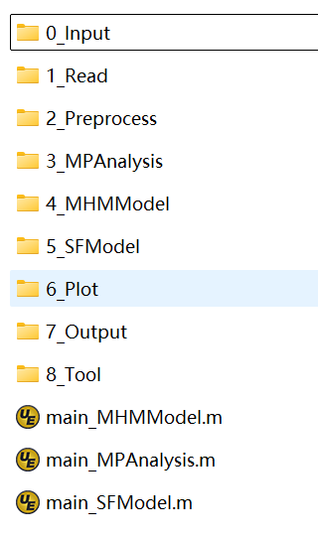

**Fig. 2** Directory structure of the MAPS

Given the variability of the input data, the following discussion will focus on the relevant contents within the **0_Input** folder. Specifically, **0_Input** folder includes the data files needed in the MAPS. As shown in Fig. 3, in the multipath analysis module, the observation file, precise ephemeris file, precise clock file, broadcast ephemeris file, DCB file, ATX file, and C/N0 file are needed. Since the data files required for multipath processing module (i.e., the MHM and SF modeling) are similar, the data files required for the two modules is put together in this folder. Several different types of residual files and broadcast ephemeris files are used in the MAPS, where the sources of the used raw files are summarized in Table 1.

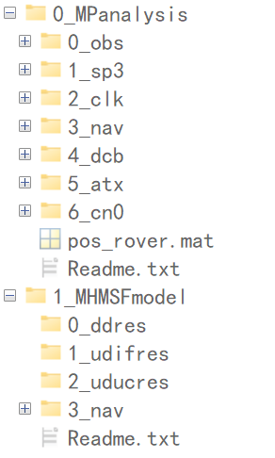

**Fig. 3** Directory structure of the ‘0_Input’ folder

**Table 1** Sources of the used raw files

|  |  |  |
| --- | --- | --- |
| Files type | Example | Source |
| Precise ephemeris | WUM0MGXFIN_20240070000_01D_05M_ORB.SP3 | ftp://igs.gnsswhu.cn/pub/gnss/products/mgex/ |
| Precise clock | WUM0MGXFIN_20240070000_01D_30S_CLK.CLK |
| Broadcast ephemeris | BRDM00DLR_S_20240070000_01D_MN.rnx | ftp://igs.gnsswhu.cn/pub/gps/data/daily/ |
| DCB | CAS0MGXRAP_20240070000_01D_01D_DCB.BSX | https://data.bdsmart.cn/pub/product/bias/ |
| ATX | igs.atx | https://files.igs.org/pub/station/general/ |
| DD residual | 2024007.ddres | Calculated from the RTKLIB software |
| UDIF residual | 2024007.udifres |
| UDUC residual | 2024007.uducres |
| Observation | 2024007.obs | Self-observed |

As shown in Table 1, it is noted that the DDRES, UDIFRES, and UDUCRES files can be calculated by the RTKLIB software and can be found in the github website (<https://github.com/GCCProTeam/MAPS_ResidualDatasets>). Table 2 lists the satellite periods of GPS, GLONASS, Galileo, and BDS. Since the longest satellite period is approximately 10 sidereal days, the 10-day residuals are prepared here. In addition, it is worth noting the specific encoding formats of the residual files used in the MAPS. When preparing these residual files, it is necessary to ensure the consistency and correctness of the file formats, which is related to the subsequent processing of reading residual files. Examples of three types of the residual file formats are given below. Figs. 4 to 6 show the examples of DDRES, UDICRES, and UDUCRES files, respectively. Among Figs. 4 to 6, the data within the red solid frame is the satellite azimuth and elevation, and that within the green solid frame is the satellite fixed mark, phase residual, code residual, and C/N0 value. The data within the different green solid frames denote the results of different frequencies for satellites. For UDIFRES file, there is only one frequency because of using the IF model.

**Table 2** Satellite periods of GPS, GLONASS, Galileo, and BDS

|  |  |  |
| --- | --- | --- |
| System | Orbit type | Period (sidereal day) |
| GPS | MEO | $≈$ 1 |
| GLONASS | MEO | $≈$ 8 |
| Galileo | MEO | $≈$ 10 |
| BDS | GEO | $≈$ 1 |
| IGSO | $≈$ 1 |
| MEO | $≈$ 7 |

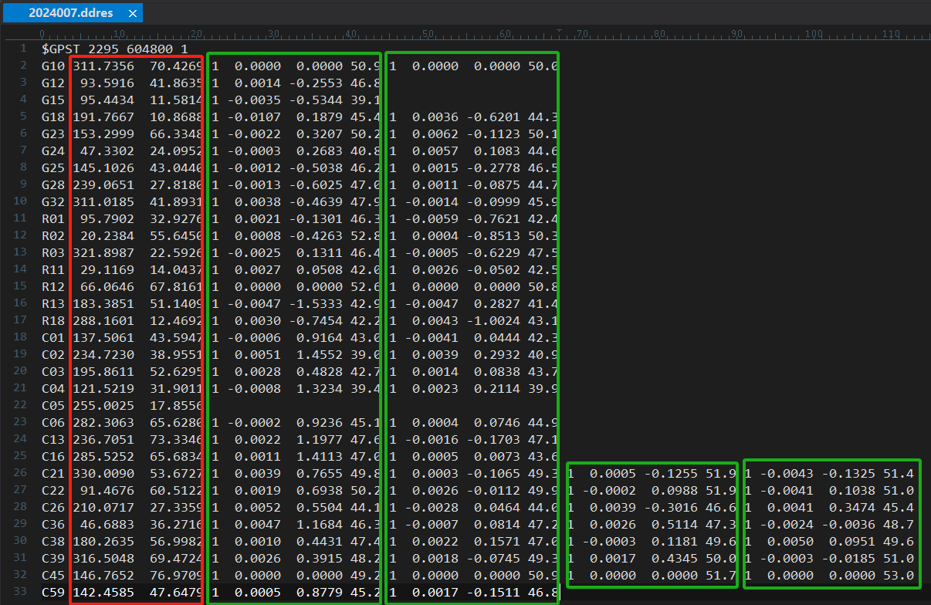

**Fig. 4** Example of DDRES file

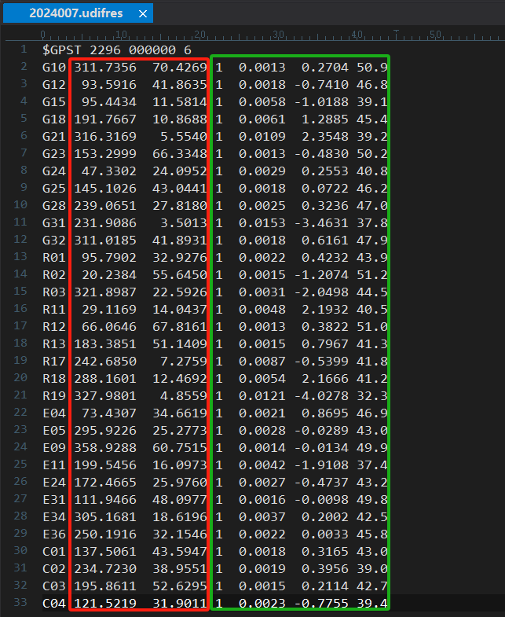

**Fig. 5** Example of UDIFRES file

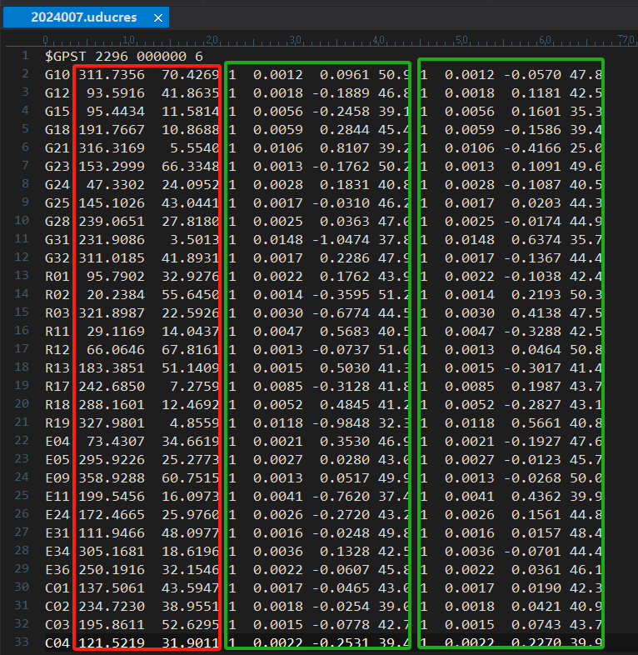

**Fig. 6** Example of UDUCRES file

# 4 How to Run the MAPS

## 4.1 MATLAB version

Although the MAPS is developed based on MATLAB 2021a, the debugging and use of the MAPS supports almost all MATLAB versions. In addition, it is worth noting that the MAPS contains the SF modeling capacity, which uses the functions in the wavelet toolbox. Certainly, the users can install the wavelet toolbox or improve the denoise method to obtain more accurate modeling results depending on the users.

## 4.2 Input data

If users want to use their own data to conduct the corresponding multipath analysis and processing using the MAPS, the users need to put their data in the corresponding folder. Meanwhile, if the users want to run the program, the corresponding settings can be changed in the script named “main_*.m”. The setting steps are introduced in the following texts below. Fig. 7 shows the corresponding files required by the multipath analysis module. If the users want to establish the C/N0 template function, only the files within the green solid wireframe are needed. In the case of CMC method, only the files within the red solid wireframe are needed. In the case of GFix and IC or GF and IC method, all files in the Fig. 7 are needed except the files within the green solid wireframe.

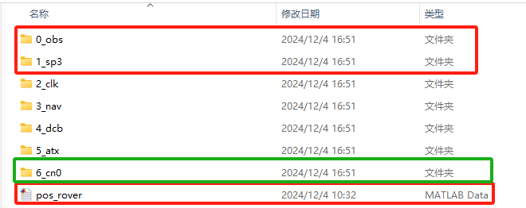

**Fig. 7** Files needed by the multipath analysis module

Fig. 8 shows the corresponding files required by the MHM modeling and SF modeling in the multipath processing module. The “RES_MHM.mat” is used for MHM modeling. The “RES_SF.mat” and “NAV.mat” are used for SF modeling. If the files of “*.mat” are missing in the folder, the users need to read the residual files and NAV files within the red solid wireframe.

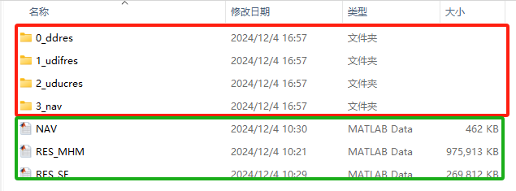

**Fig. 8** Files needed by the MHM modeling and SF modeling in the multipath processing module

## 4.3 Multipath analysis

The CMC method, GFix and IC method, GF and IC method, or the modeling of C/N0 template function needs to be set and executed in script named “main_MPAnalysis.m”. The following demonstrates the corresponding steps to run the “main_MPAnalysis.m” with sample data.

**Step 1: Constants.**

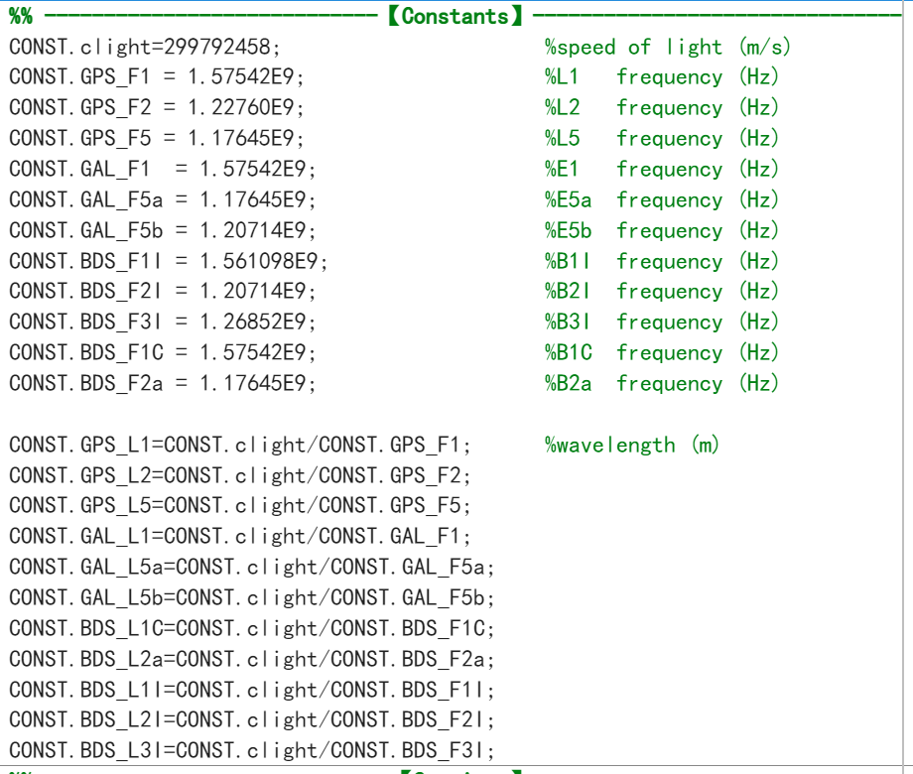

**Step 2: Settings.**

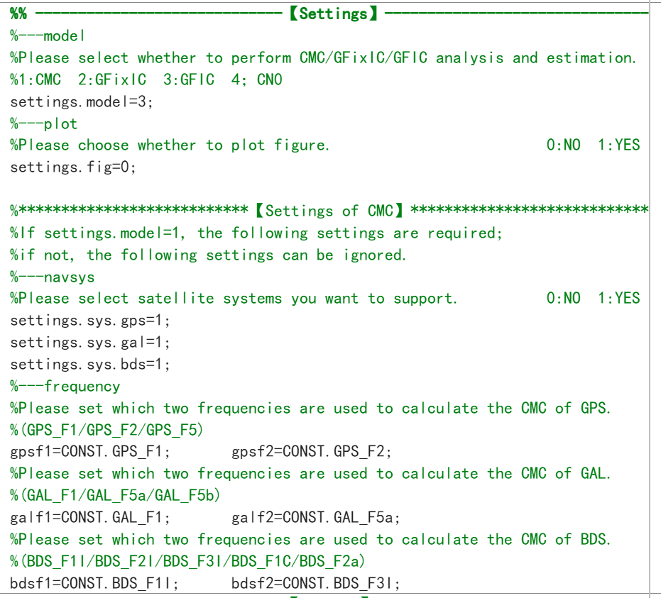

**Step 3: Set the file path. Please prepare the corresponding data files and place them in the corresponding folder.**

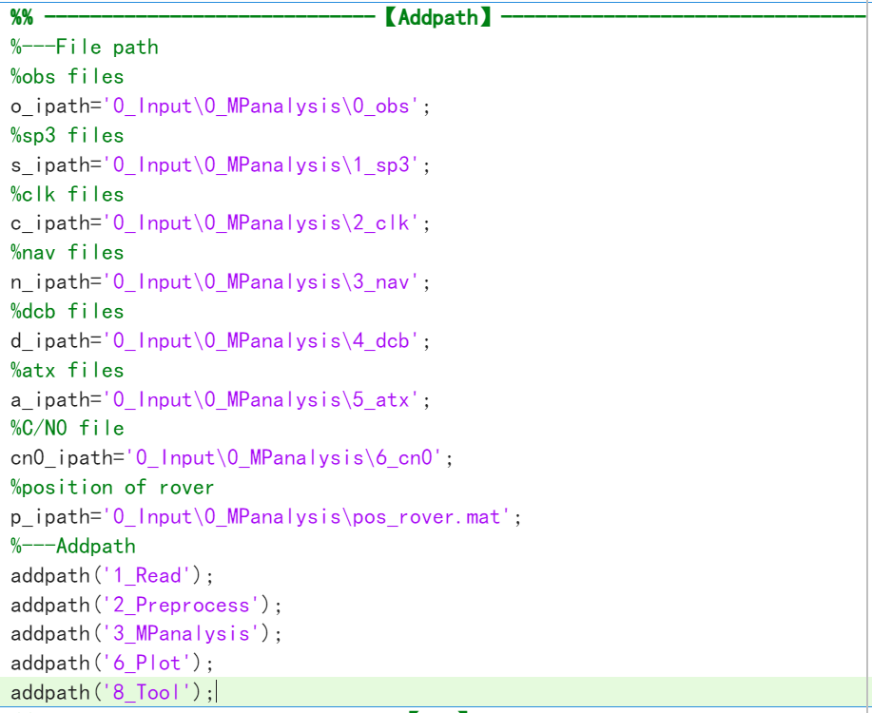

**Step 4: Run the CMC method, GFix and IC method, GF and IC method, or the modeling of C/N0 template function.**

**Step 5: Plot the corresponding results of the CMC method, GFix and IC method, GF and IC method, or the modeling of C/N0 template function.**

## 4.4 MHM modeling

The MHM modeling needs to be set and executed in the script named “main_MHMModel.m”. The using of DDRES, supporting of four systems and modeling of five types of MHM models are as examples to demonstrate the corresponding steps in the following texts. It is noted that the MHM modeling involves the selection of different systems, different frequencies, and different residual types, which are all located in the setting part of the script. Hence, the setting part is mainly introduced here, and the modeling part is briefly introduced.

**Step 1: Settings.**

1. Set the supported satellite systems.

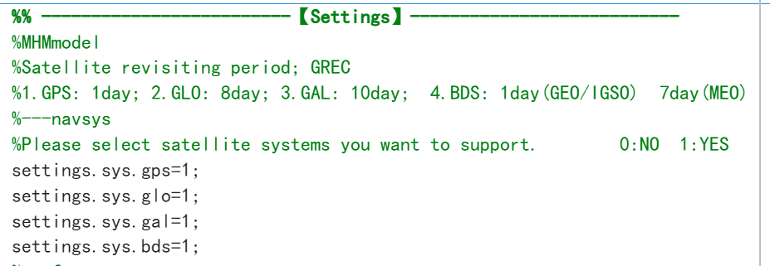

1. Set the supported frequencies. It is noted that the settings of supported frequencies should obey the settings of supported systems.

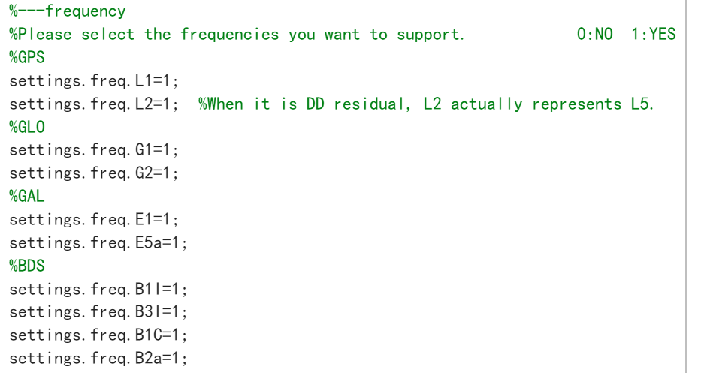

1. Set the supported MHM models. It is noted that multiple models can be set here at the same time.

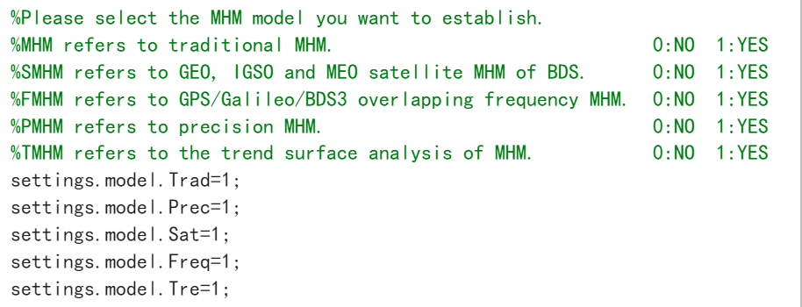

1. Set the type of residual used for modeling and choose whether to use residuals from fixed solution or float solution.

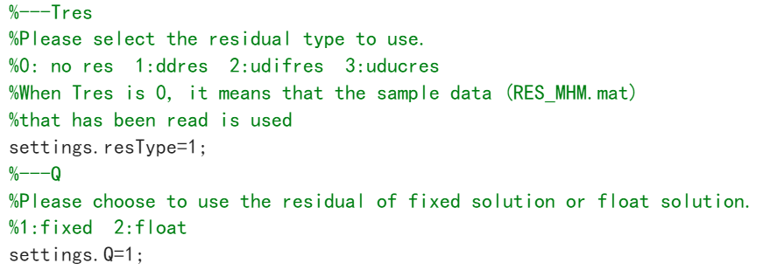

1. Set the grid resolution of the model to be established.

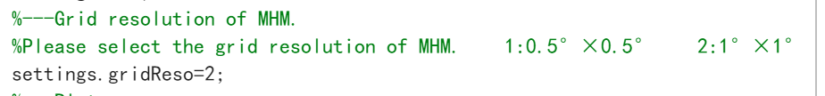

1. Set the type of plotting.

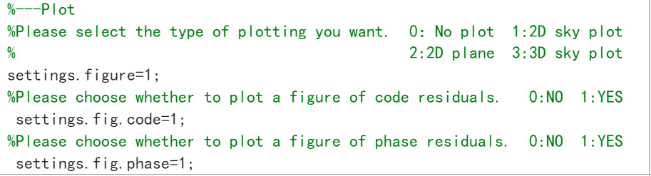

**Step 2: Set the file path. Please prepare the corresponding data files and place them in the corresponding folder.**

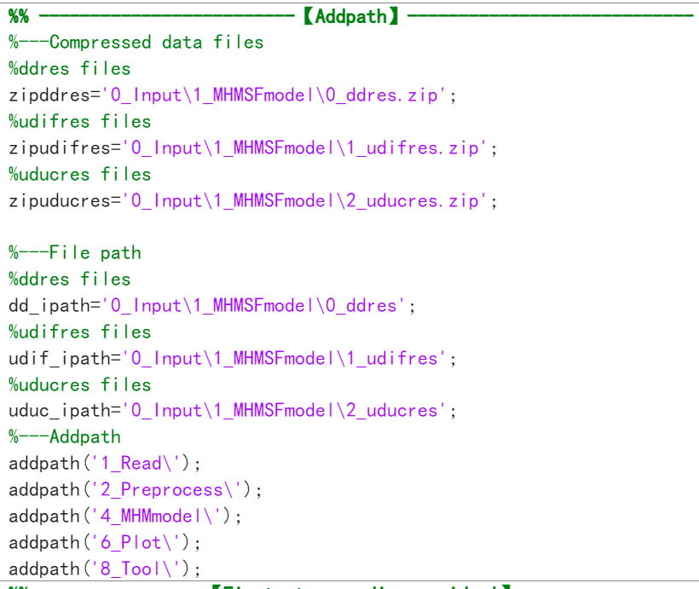

**Step 3: Run the MHM modeling. This step is divided into three sub-steps: reading residuals, modeling, and plotting.**

1. Reading residuals. According to the above settings, the DDRES will be read. Here, the ‘SD_fix’ stores the SD residuals of fixed solutions, which is assigned to ‘RES’. (Note: This step may take a long time.)
2. Modeling. The used examples establish five types of models, and the modeling results are stored in the corresponding structures.
3. Plotting. The corresponding plotting examples will be given in the Chapter 5.

## 4.5 SF modeling

The SF modeling needs to be set and executed in the script named “main_SFModel.m”. The using of UDUCRES, supporting of GPS, Galileo, and BDS systems, and modeling of two types of SF models are as examples to demonstrate the corresponding steps in the following texts. It is noted that the SF modeling involves the selection of different systems, different frequencies, and different residual types, which are all located in the setting part of the script. Hence, the setting part is mainly introduced here, and the modeling part is briefly introduced.

**Step 1: Settings.**

1. Select the supported satellite systems. It is noted that only GPS, Galileo, and BDS systems are supported.

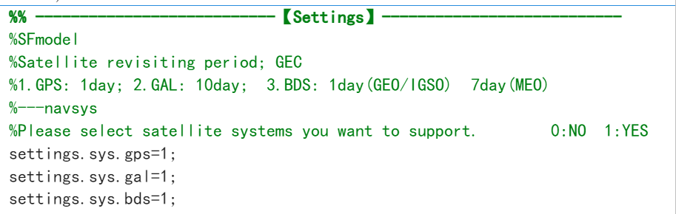

1. Set the supported frequencies. It is noted that the settings of supported frequencies should obey the settings of supported systems.

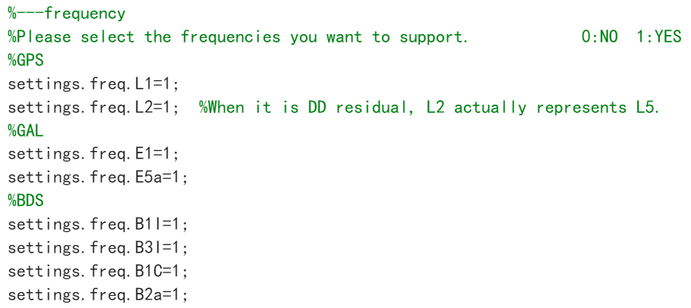

1. Set the supported SF models. It is noted that multiple models can be set here at the same time.

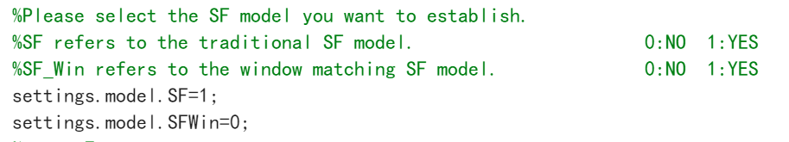

1. Set the type of residual used for modeling and choose whether to use residuals from fixed solution or float solution.

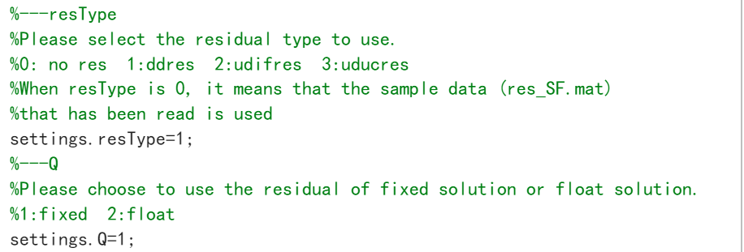

1. Set the window size (if the SF_Win model is not supported, the window size can be set to 0.)

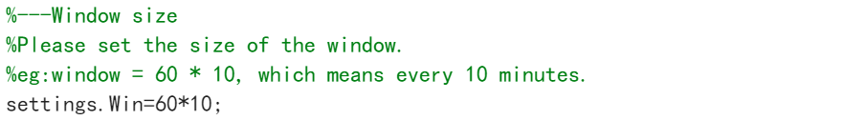

**Step 2: Set the file path. Please prepare the corresponding data files and place them in the corresponding folder.**

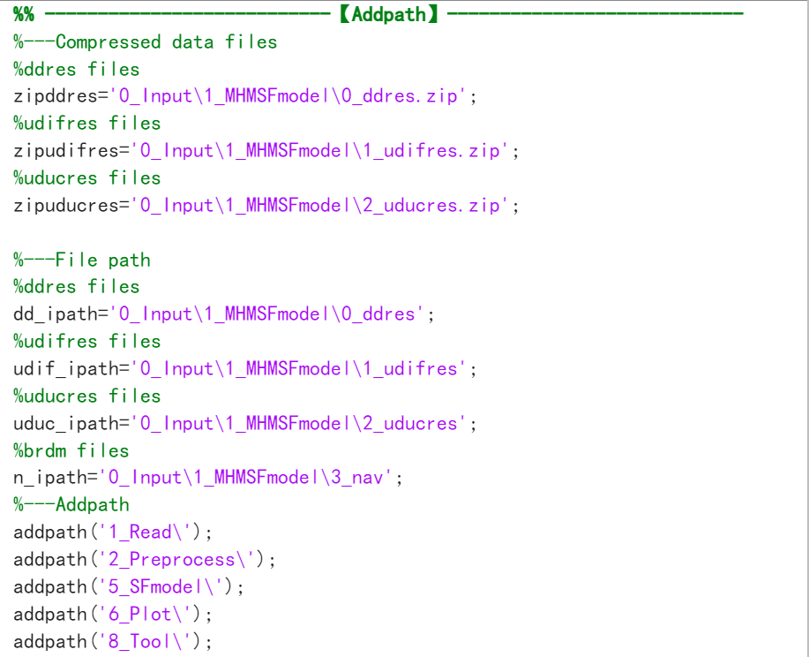

**Step 3: Run the SF modeling. This step is divided into four sub-steps: reading residuals, reading broadcast ephemeris, modeling, and plotting.**

1. Reading residuals. According to the above settings, the UDUCRES will be read. Here, the ‘UDUC’ and ‘UDUC1’ store the undifferenced and uncombined residuals, which are assigned to ‘RES’ and ‘RES1’, respectively. (Note: This step may take a long time.)
2. Reading broadcast ephemeris. The broadcast ephemeris is used to calculate the satellite period.
3. Modeling. The used examples establish two types of models, and the modeling results are stored in the corresponding structures.
4. Plotting. The time series plot of the residuals of each satellite is plotted.

# 5 Plotting function

All the plotting functions are stored in **6_Plot** folder, and the plotting functions are involved in the multipath analysis and processing modules of the MAPS. It is noted that the corresponding plotting settings can be set in the corresponding script. Here, the plotting types supported in the MAPS and the corresponding examples are shown in the following texts.

## 5.1 Plotting of multipath analysis

### 5.1.1 CMC method

1. **Time series plot**

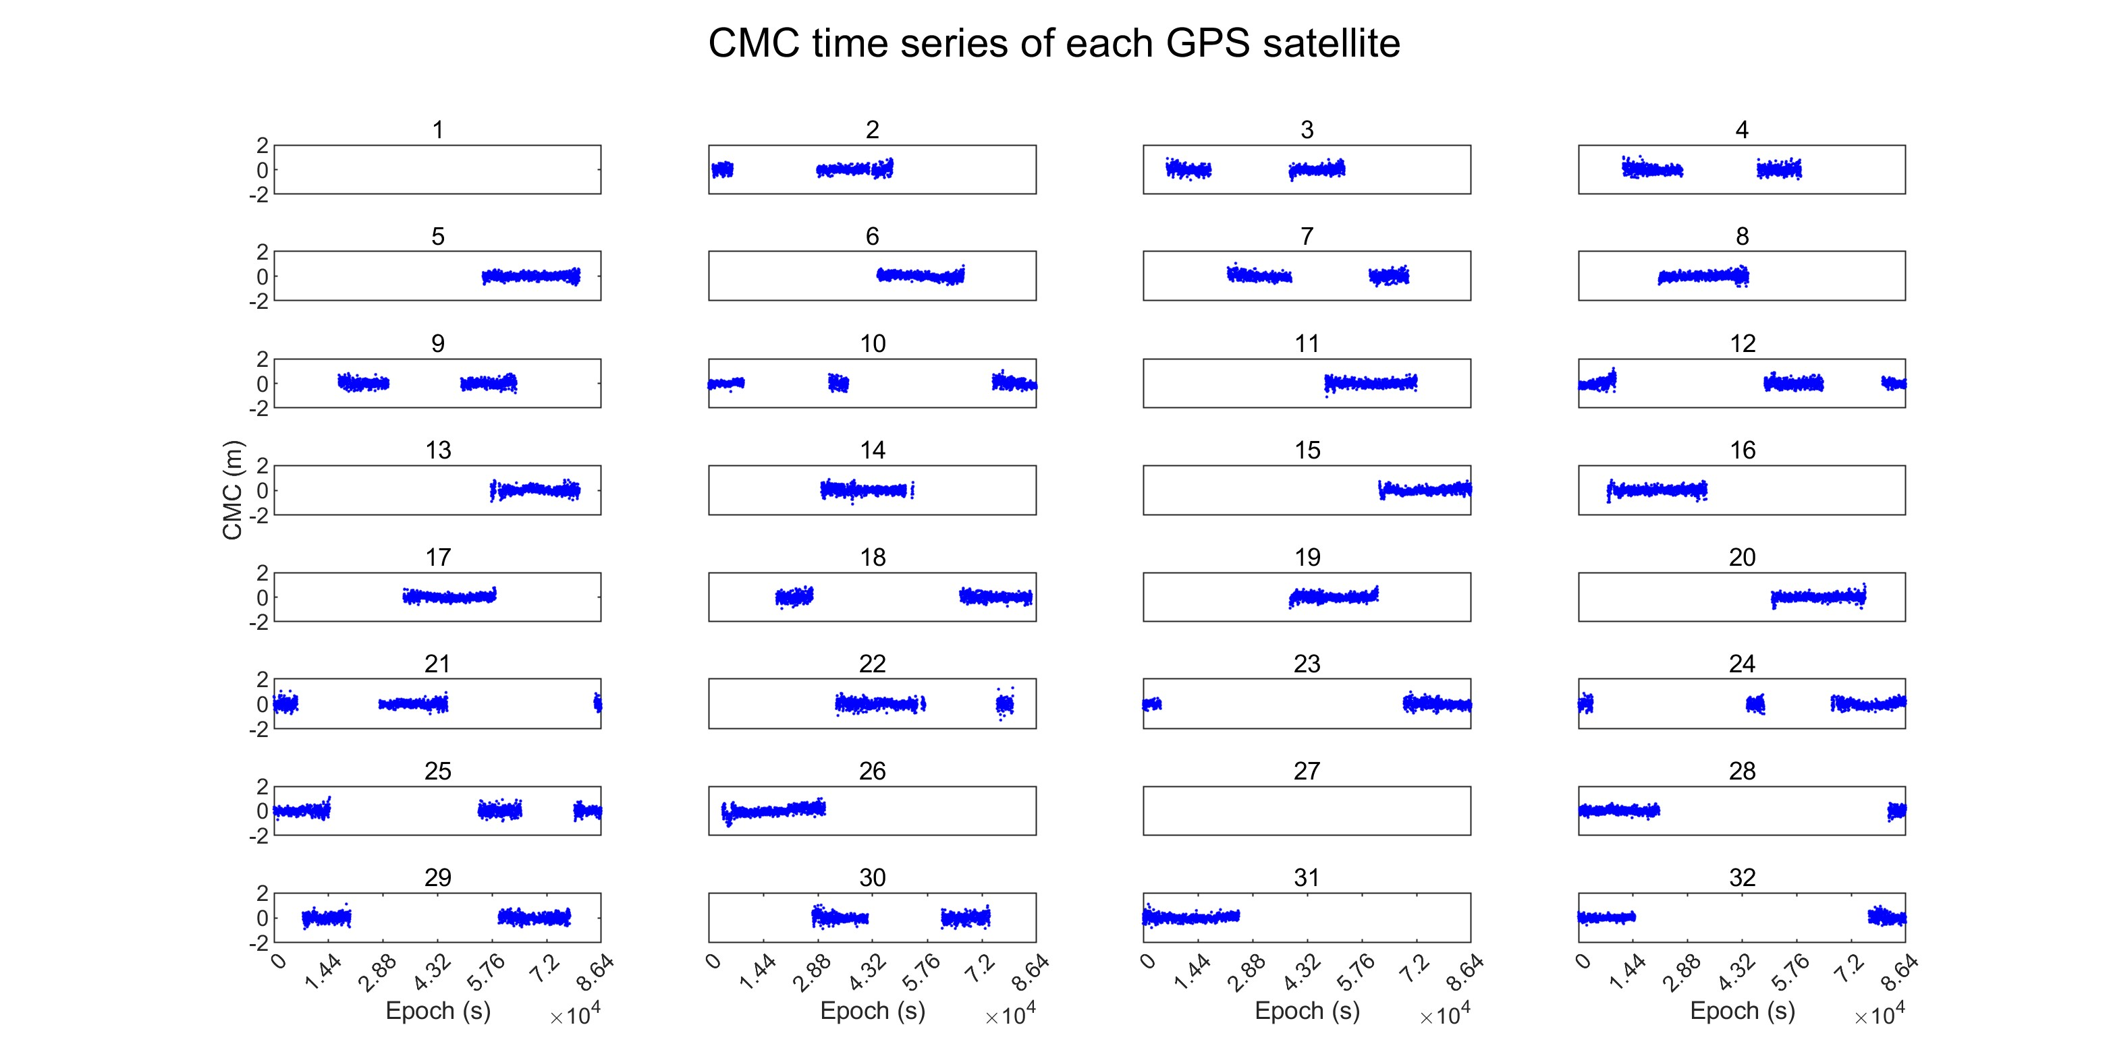

**Fig. 9** CMC time series of GPS satellites

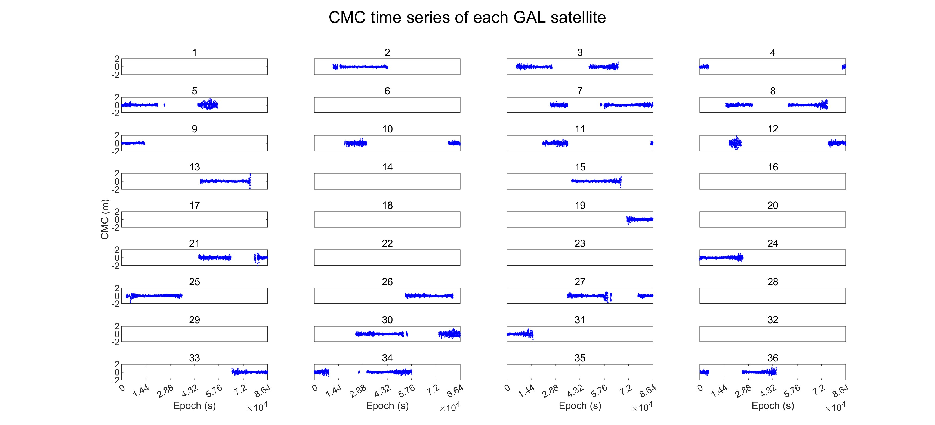

**Fig. 10** CMC time series of Galileo satellites

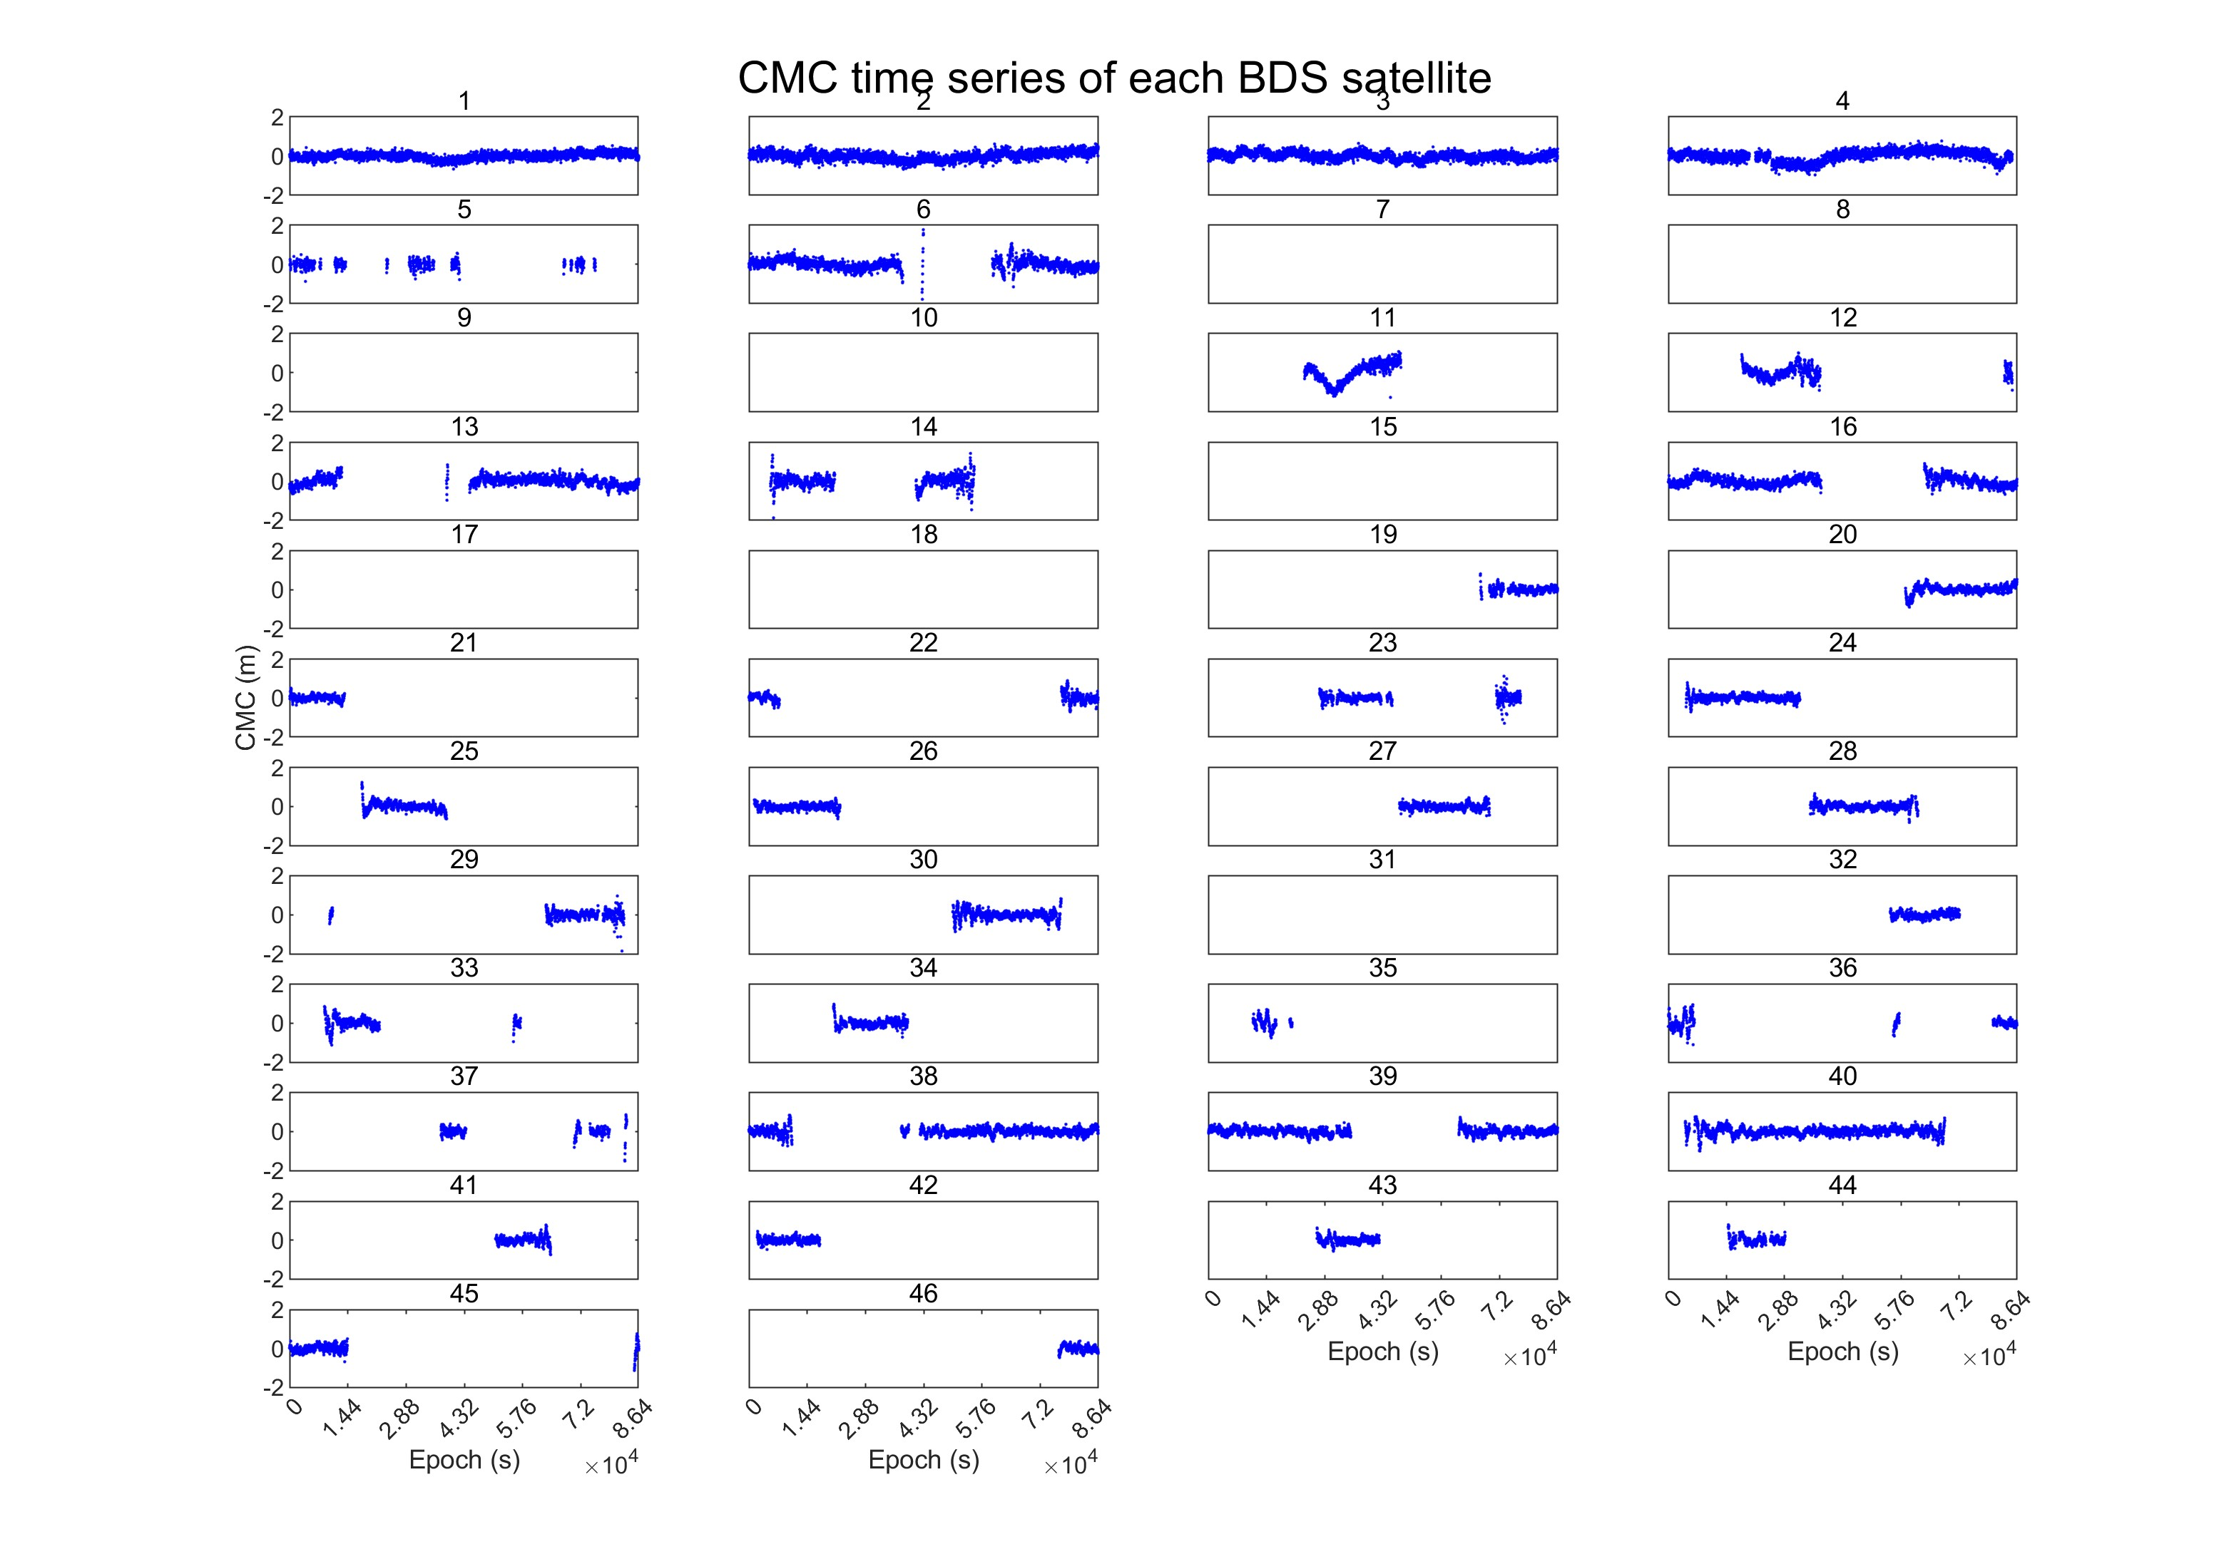

**Fig. 11** CMC time series of BDS satellites

1. **Sky plot**

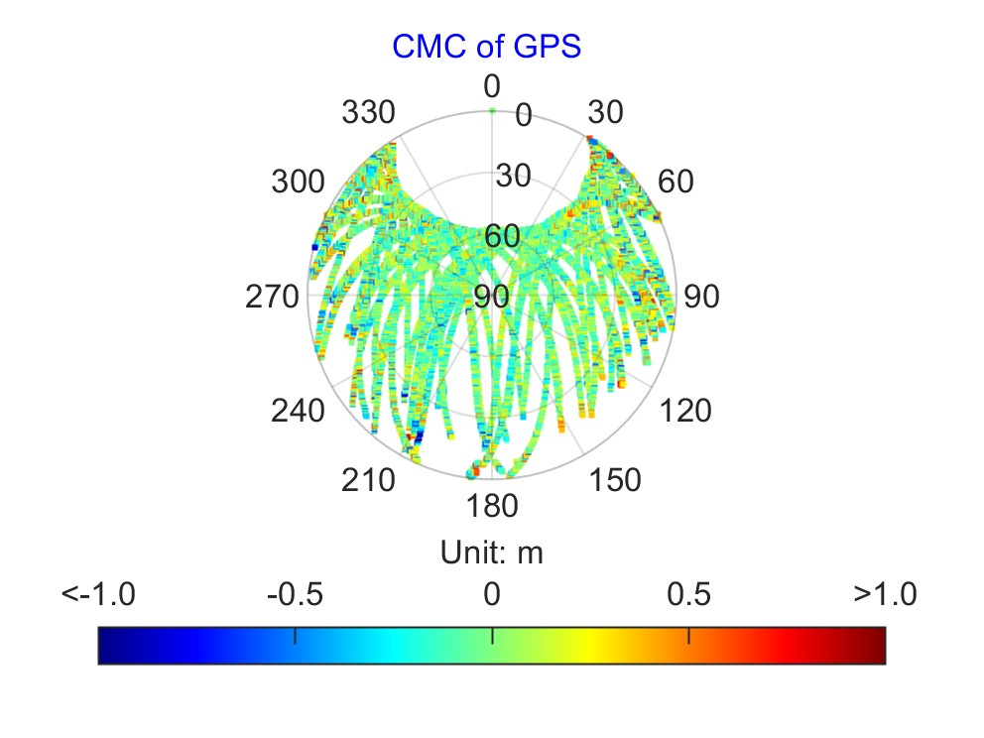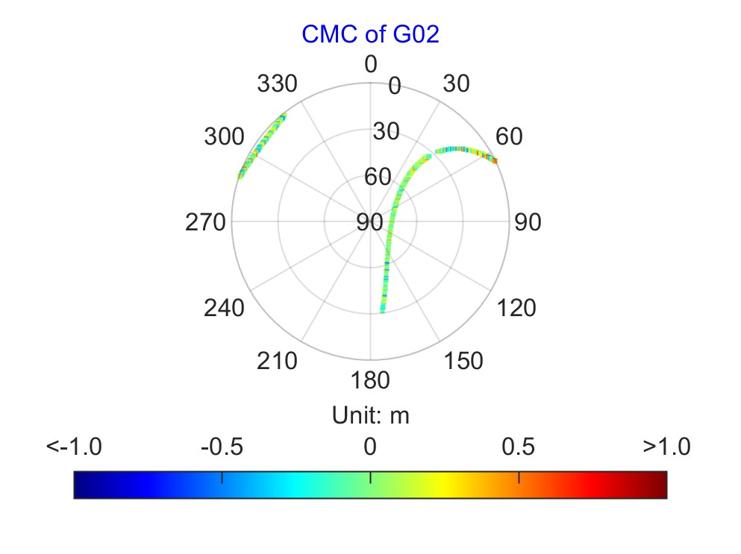

**Fig. 12** CMC sky plot of GPS satellites

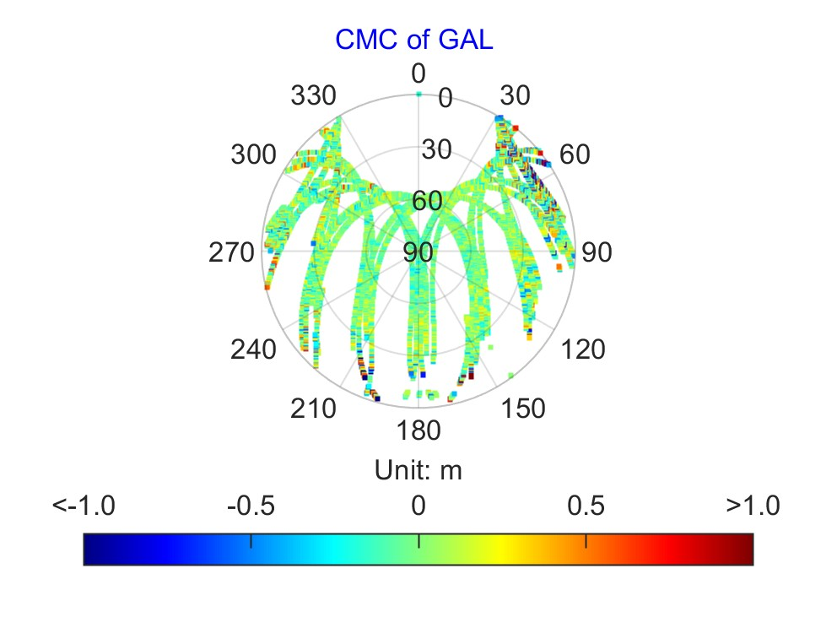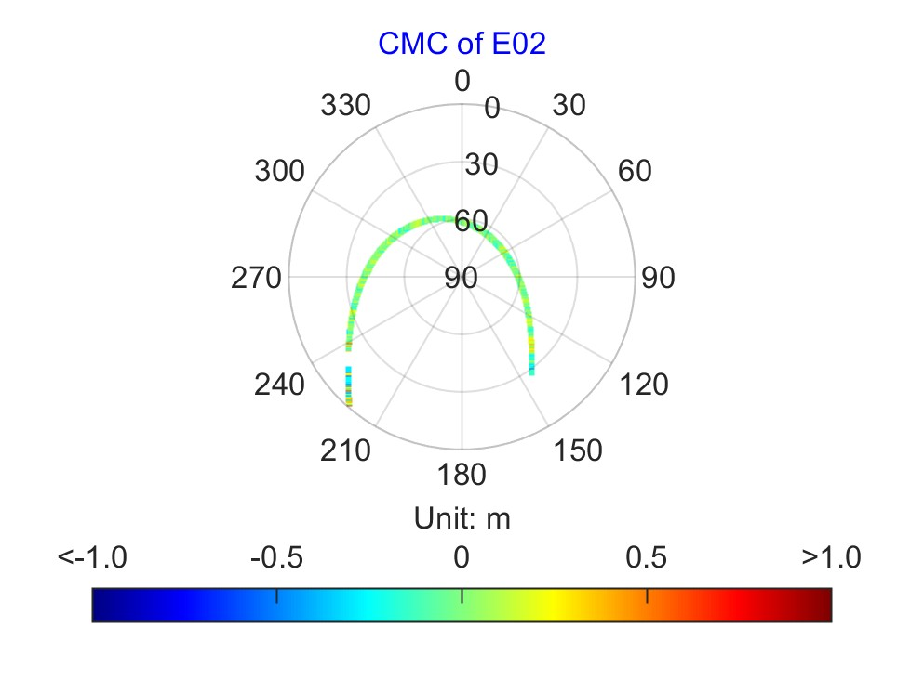

**Fig. 13** CMC sky plot of Galileo satellites

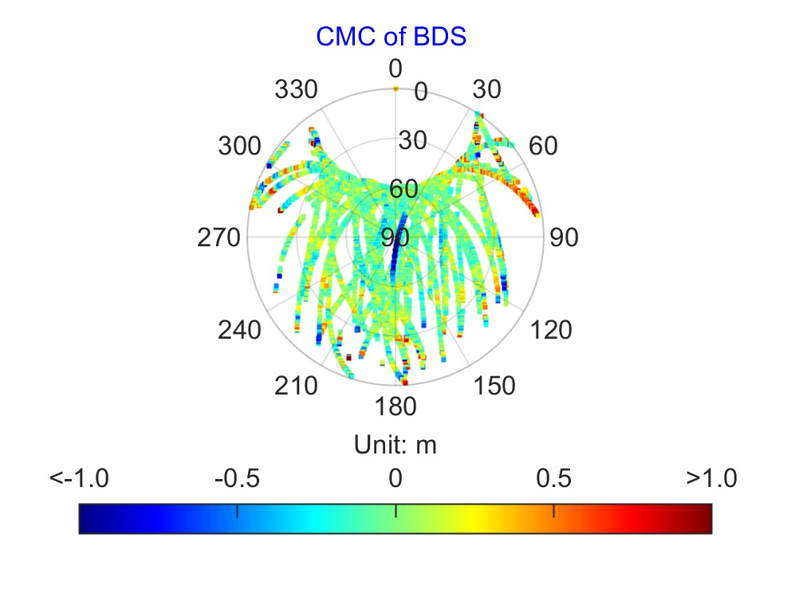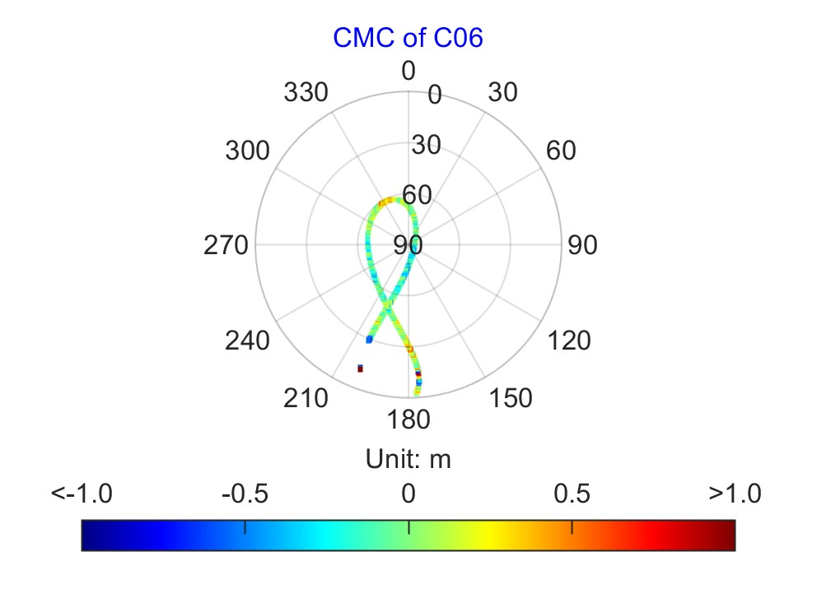

**Fig. 14** CMC sky plot of BDS satellites

### 5.1.2 GFix and IC method

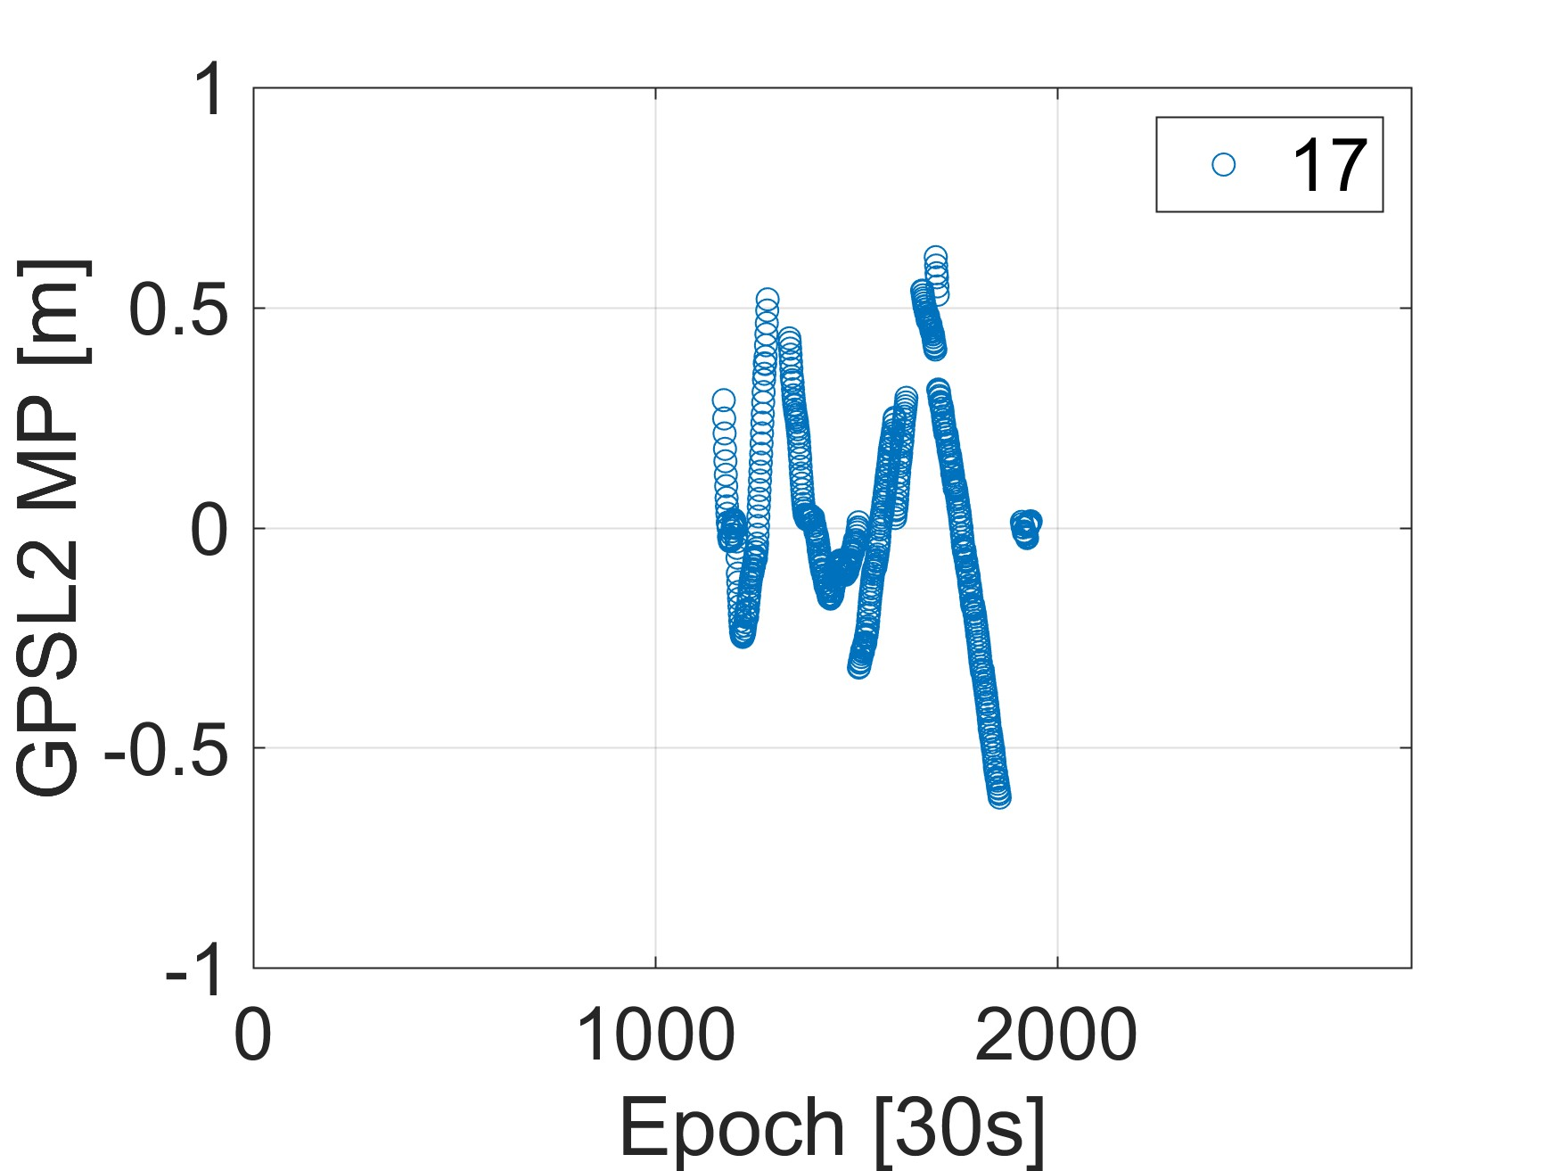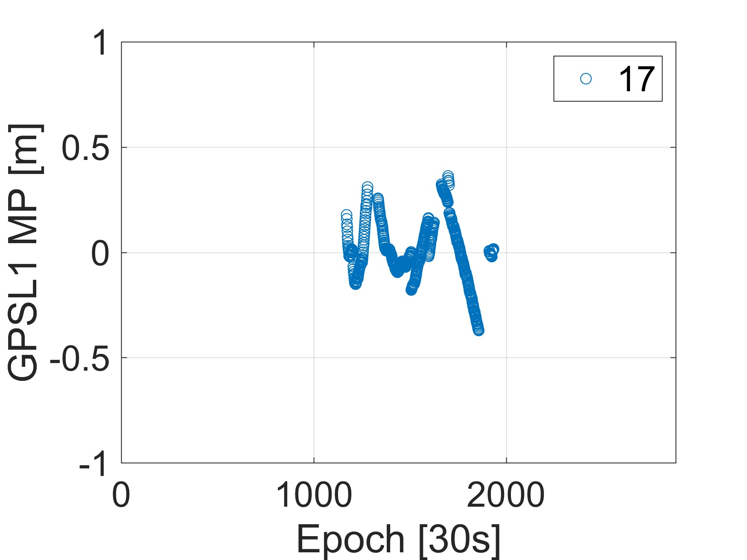

**Fig. 15** Multipath time series of L1 and L2 of G17 satellite

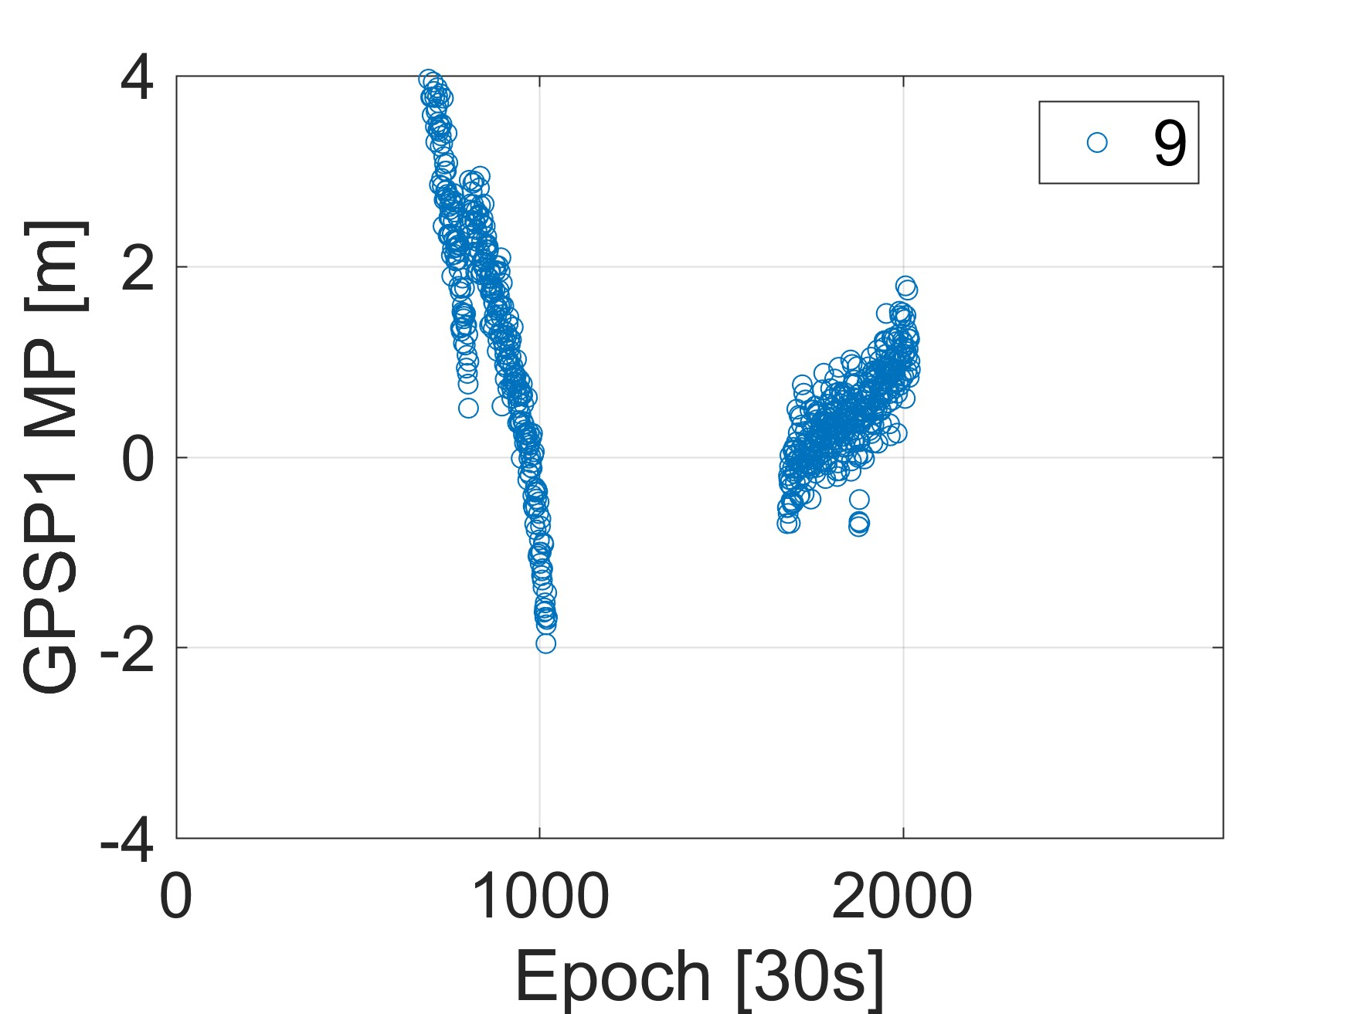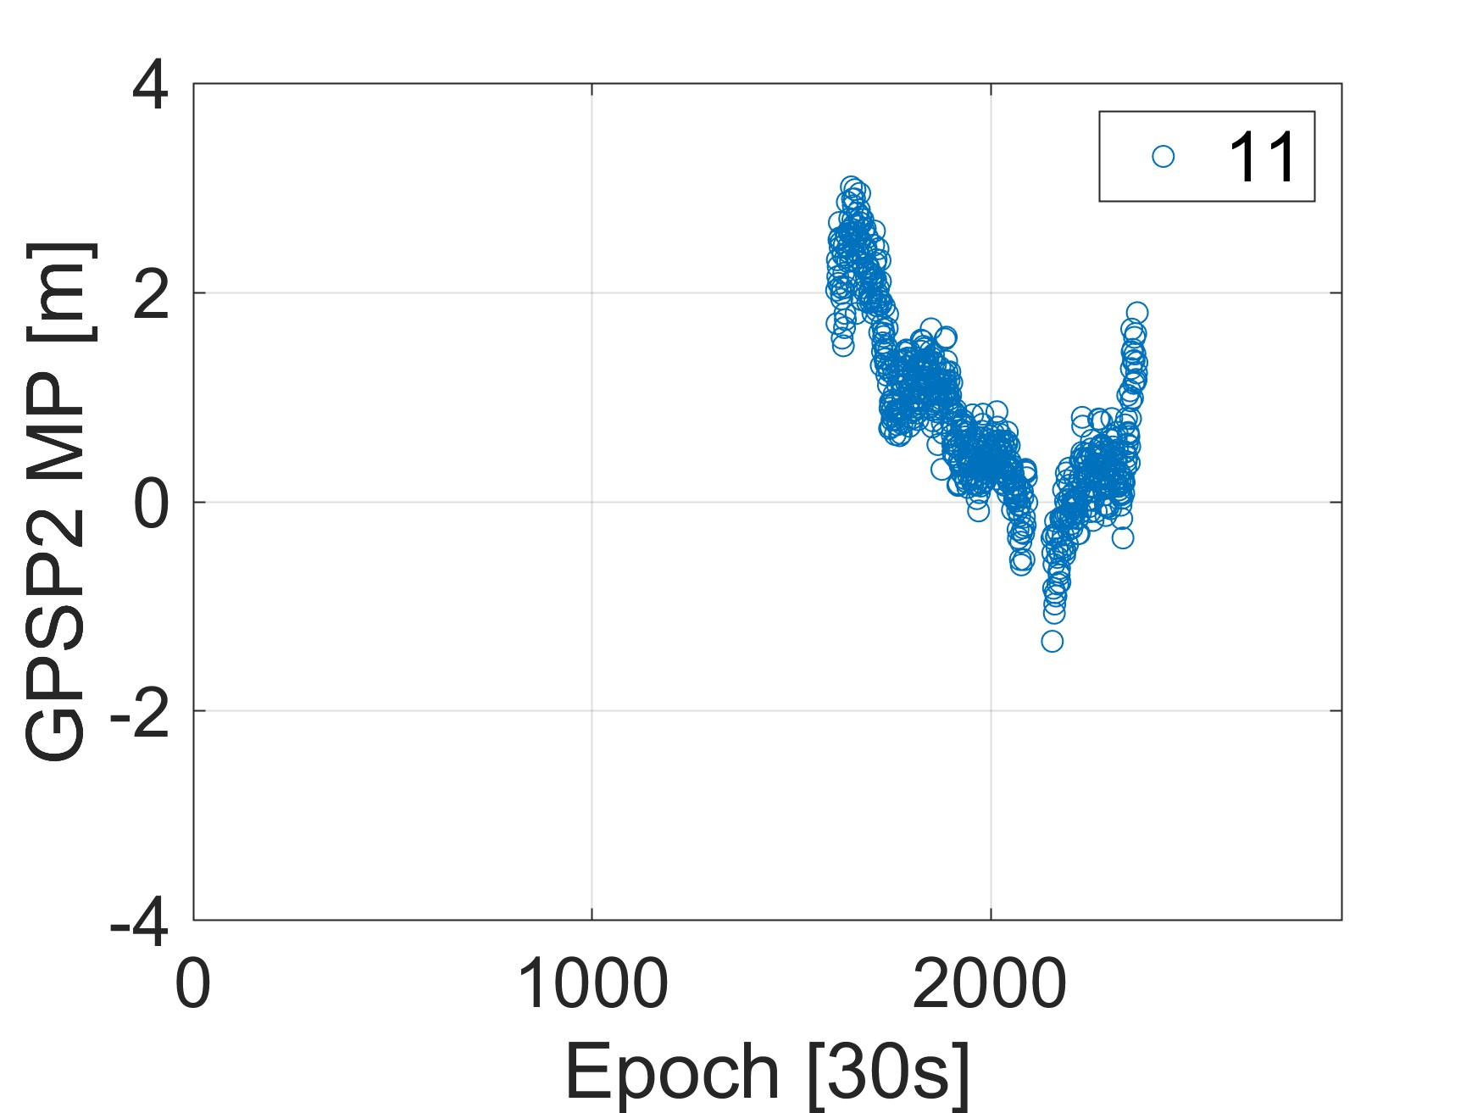

**Fig. 16** Multipath time series of P1 of G09 satellite and P2 of G11 satellite

### 5.1.3 GF and IC method

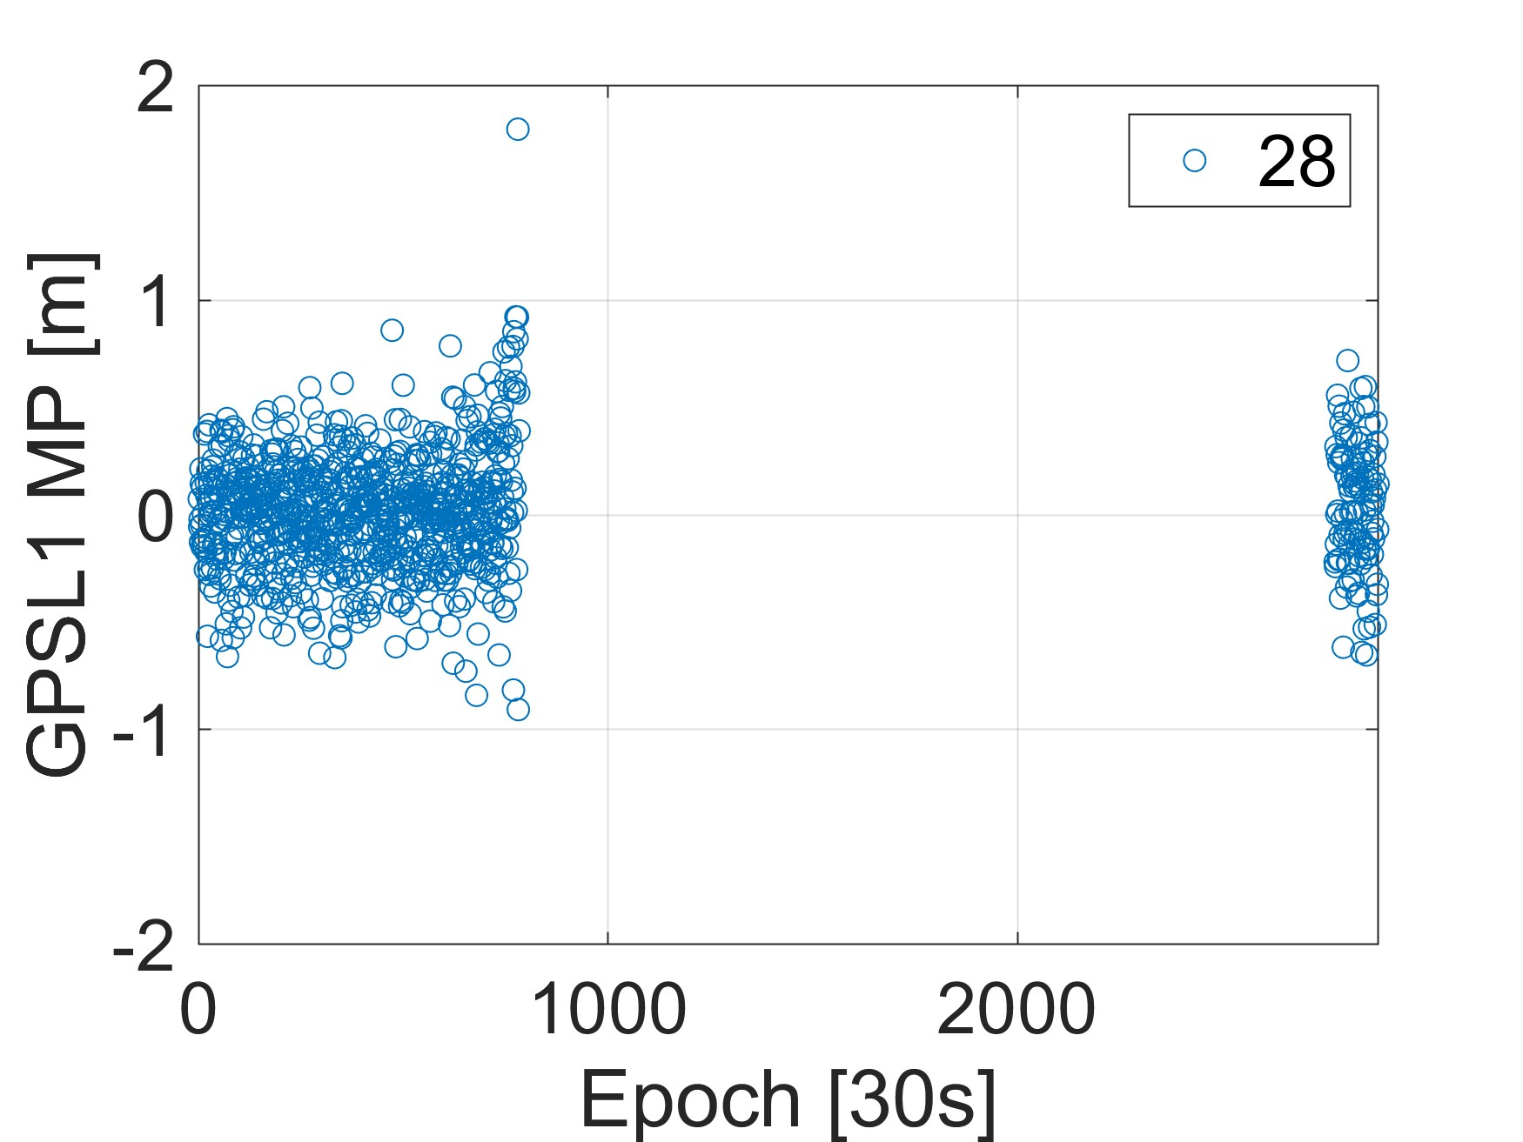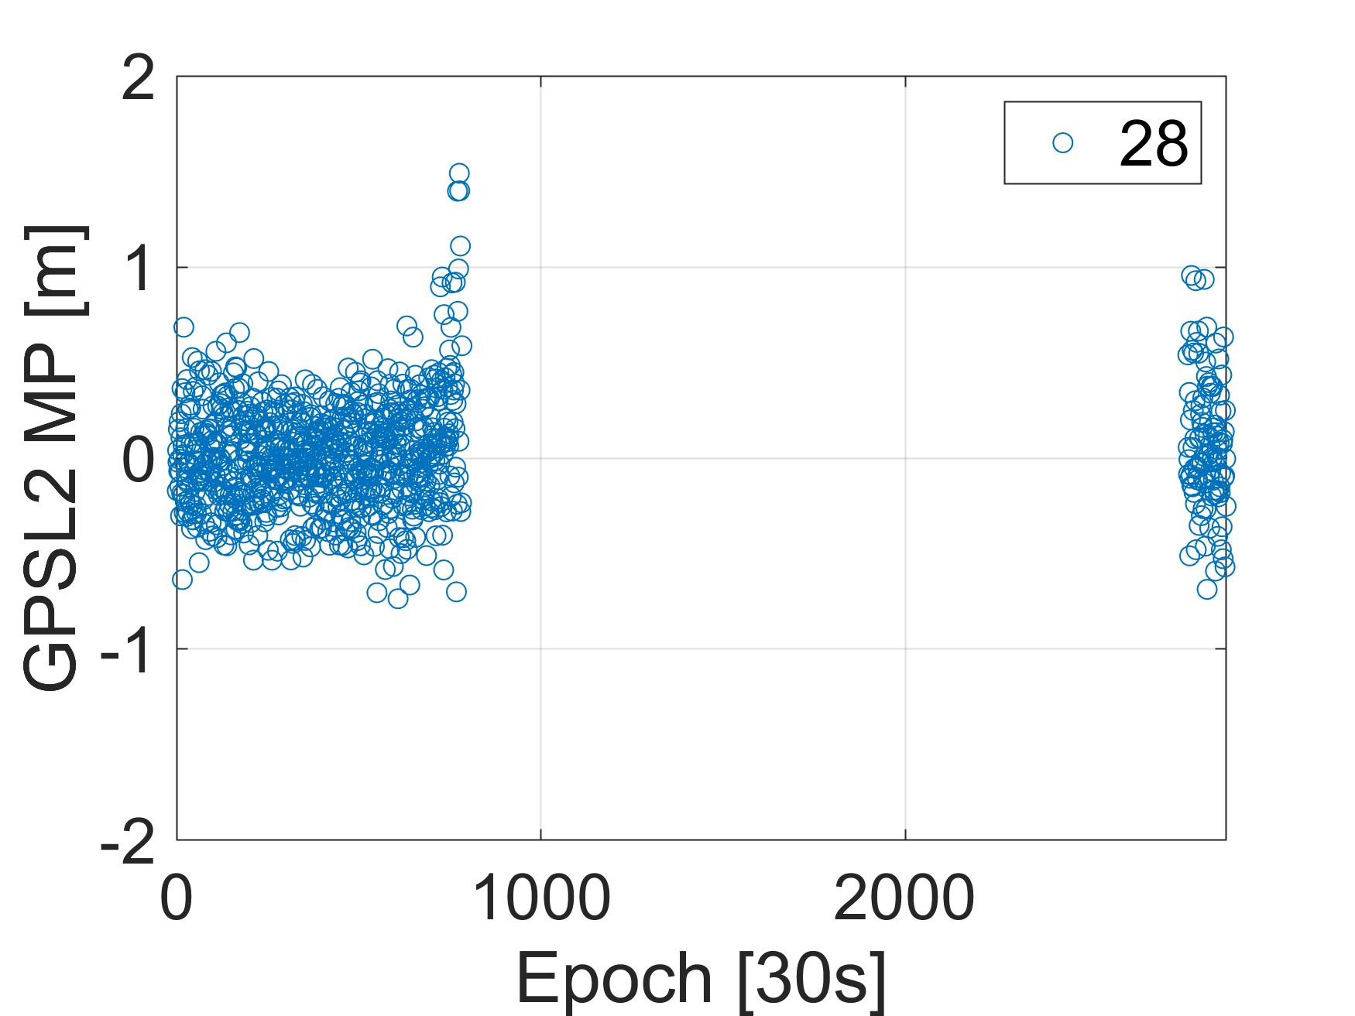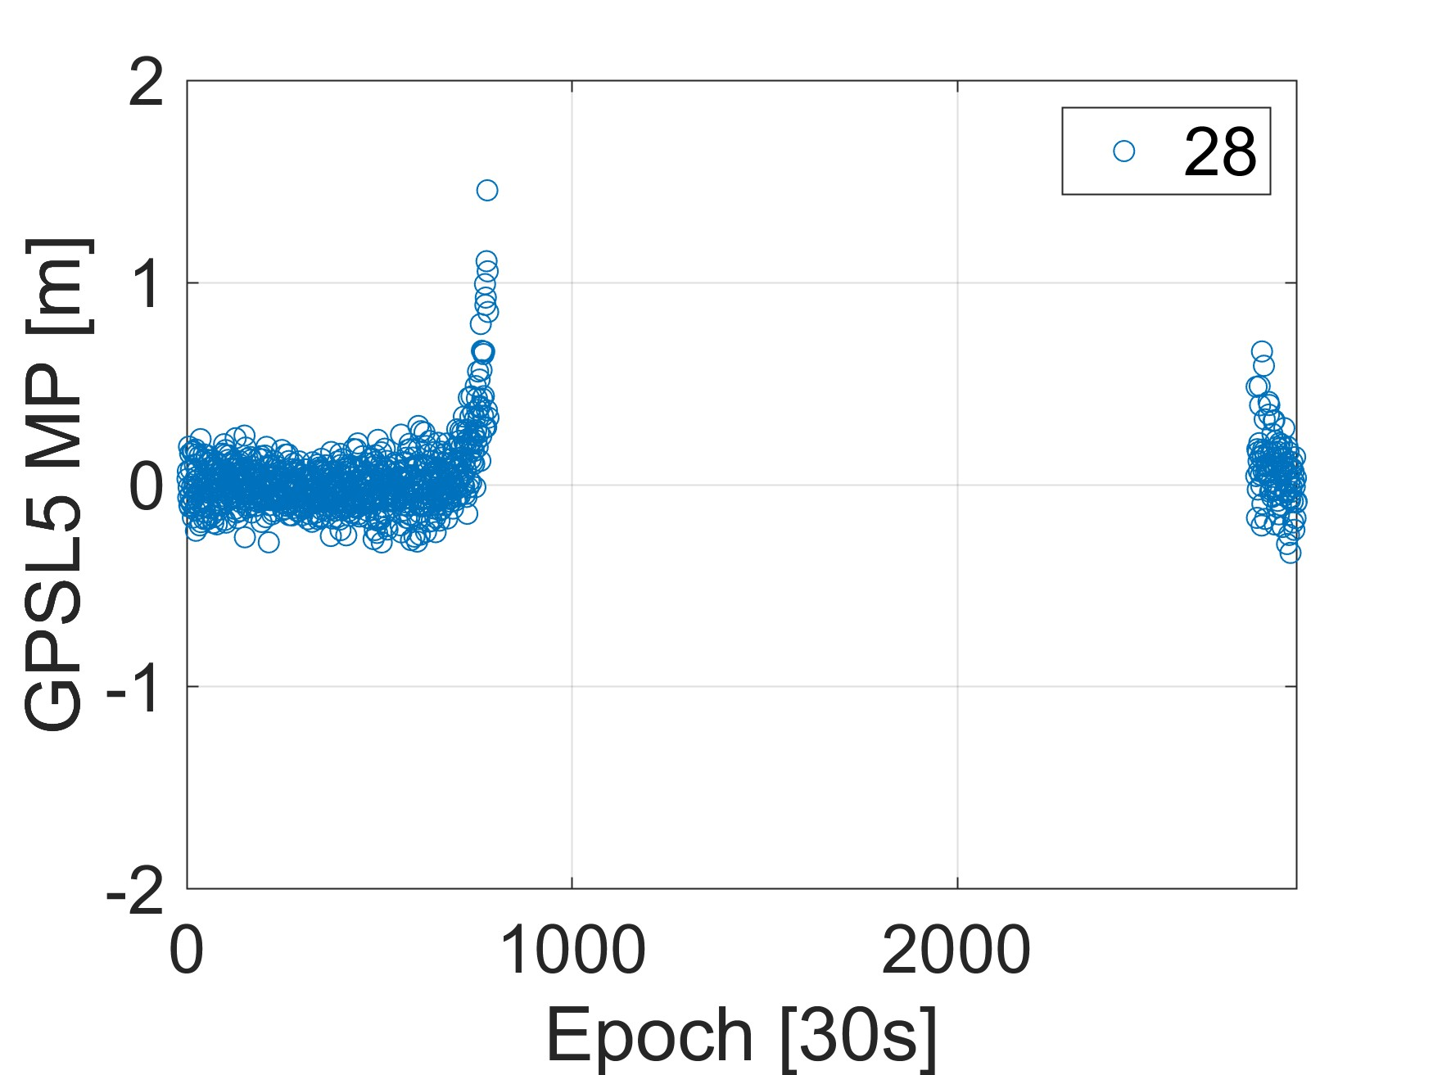

**Fig. 17** Multipath time series of G28 satellite

### 5.1.4 C/N0 template function

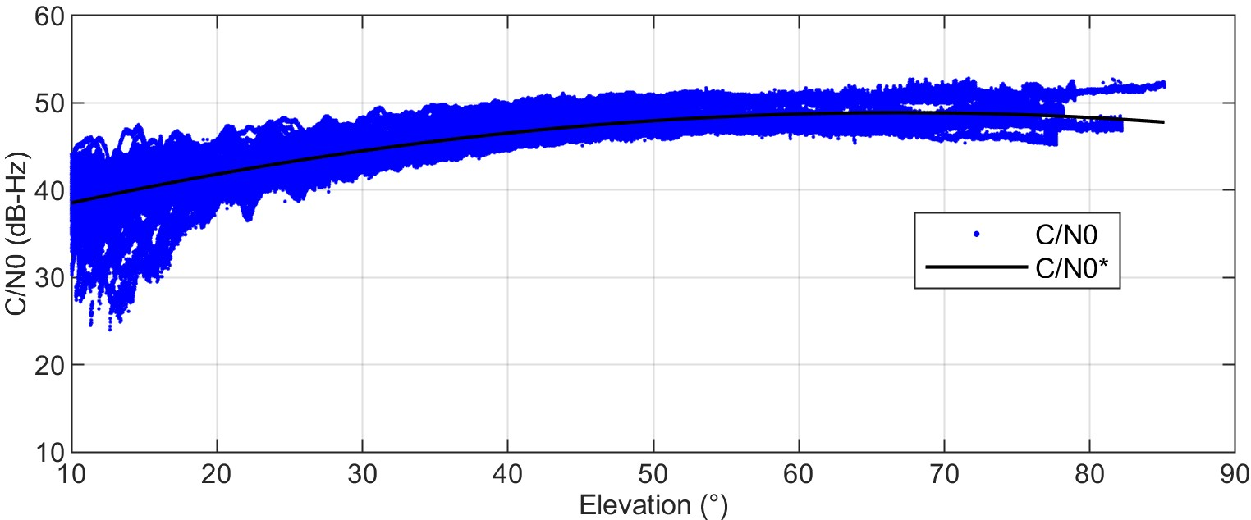

**Fig. 18** C/N0 values and C/N0 template function

## 5.2 Plotting of MHM modeling

For the MHM modeling part, the plotting of MHM, PMHM, SMHM, and FMHM are supported. The plotting types include 2D sky plot, 2D plane, and 3D sky plot.

### 5.2.1 2D sky plot

1. **MHM**

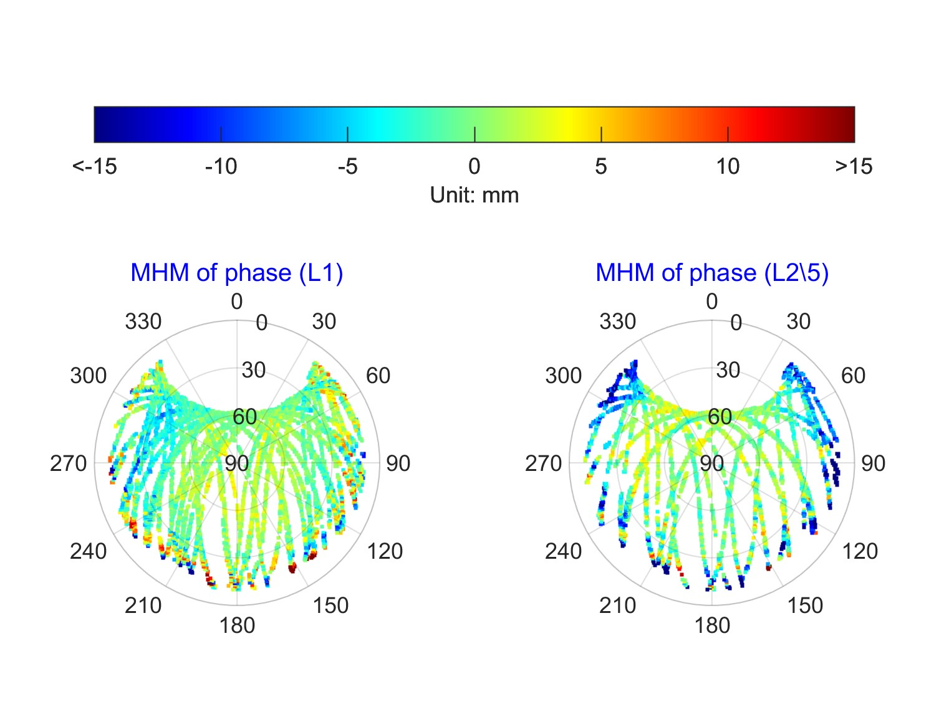

**Fig. 19** 2D sky plot of phase MHM for GPS

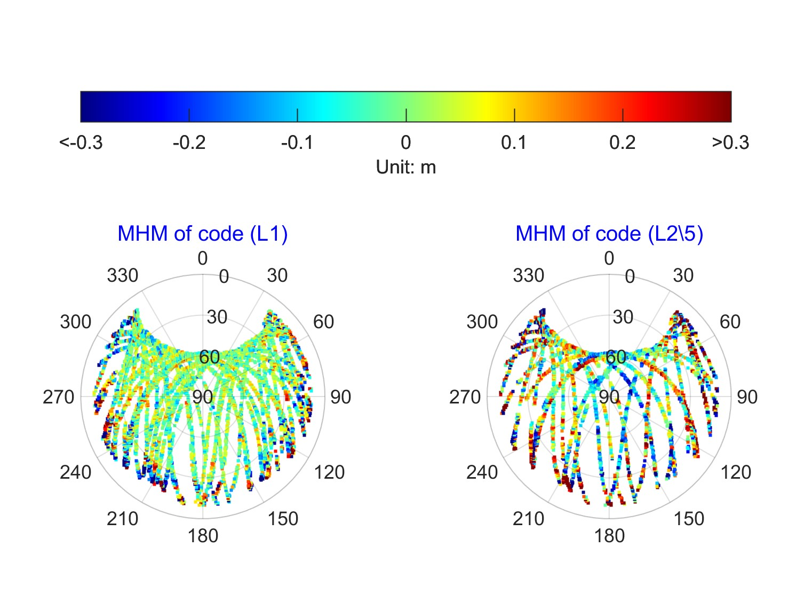

**Fig. 20** 2D sky plot of code MHM for GPS

1. **PMHM**

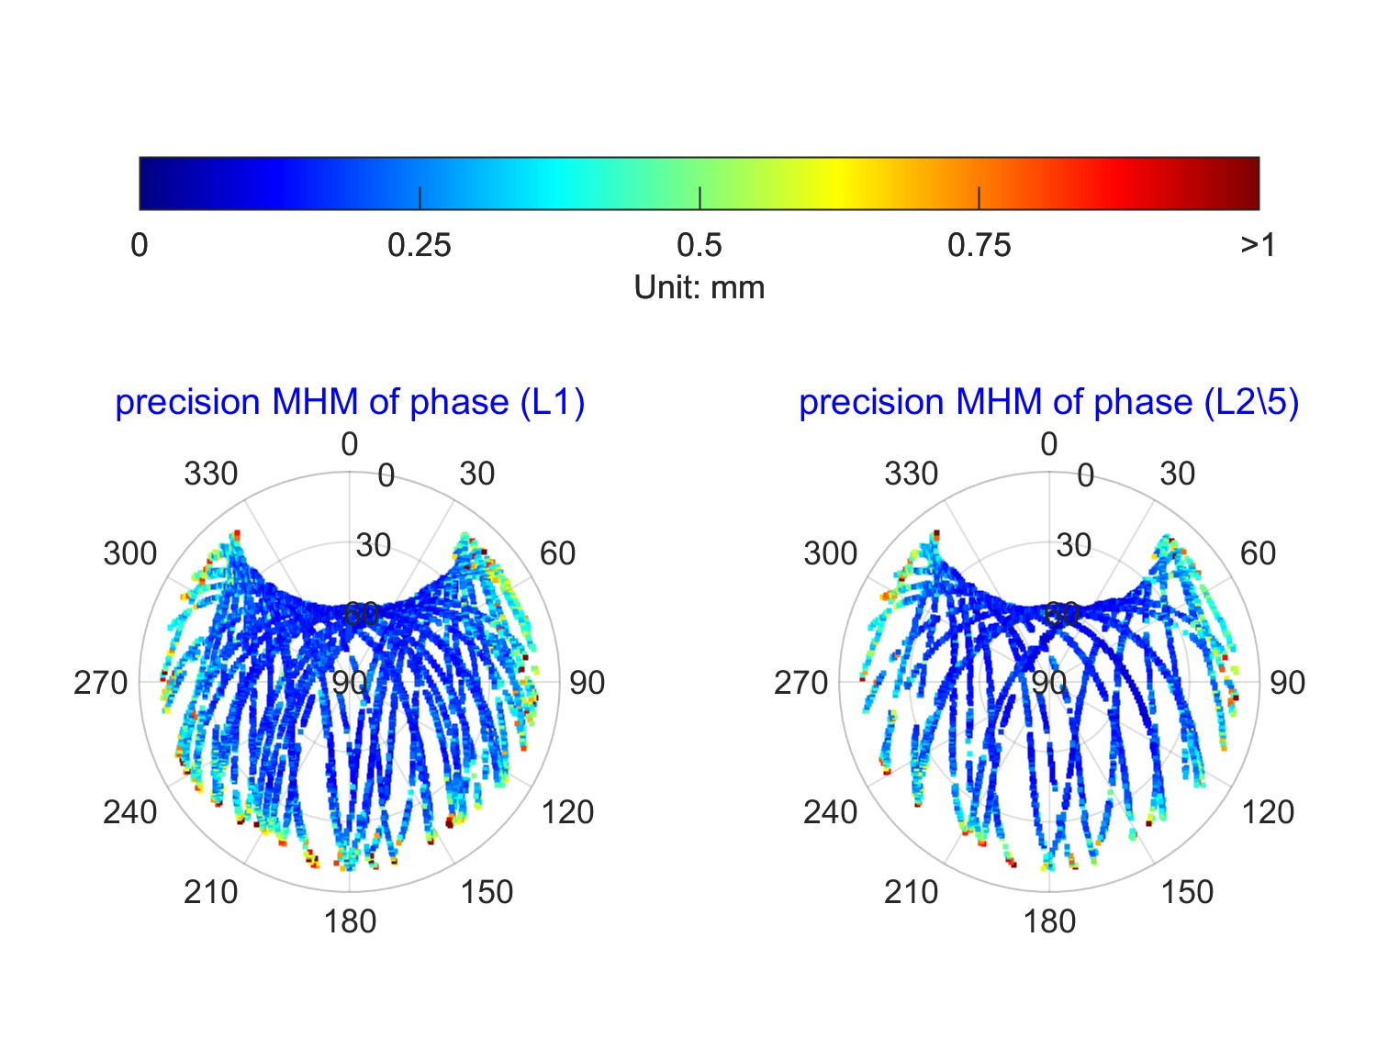

**Fig. 21** 2D sky plot of phase PMHM for GPS

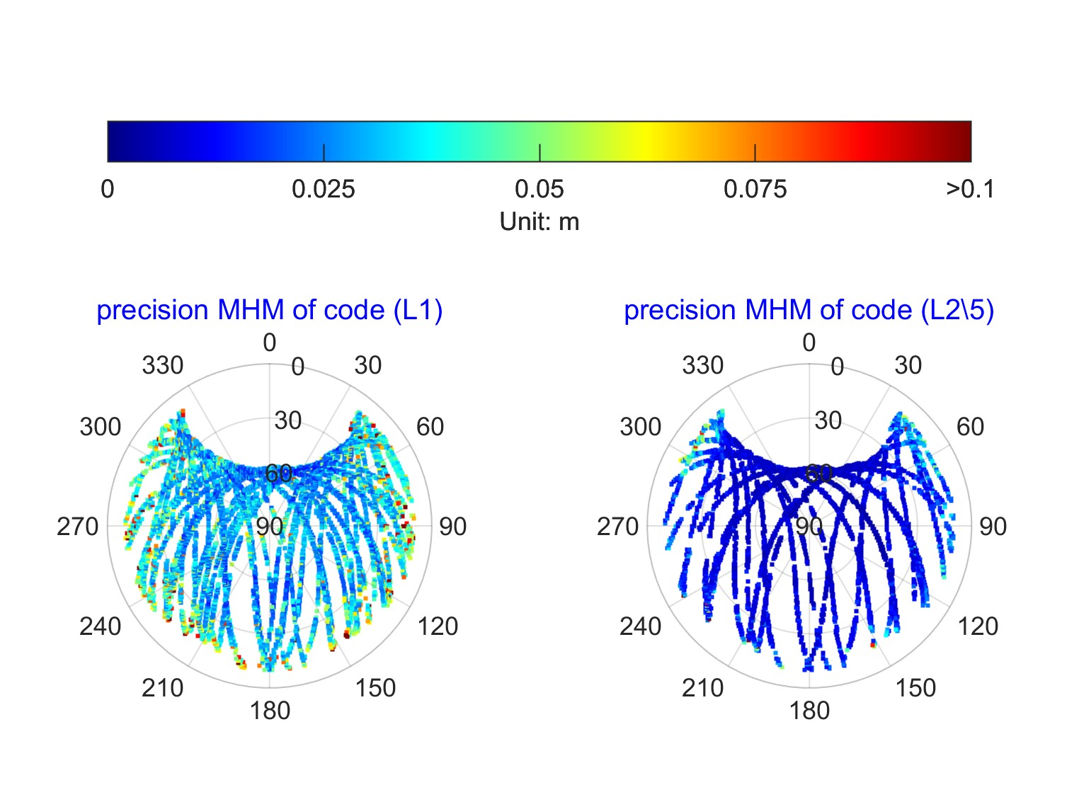

**Fig. 22** 2D sky plot of code PMHM for GPS

1. **SMHM**

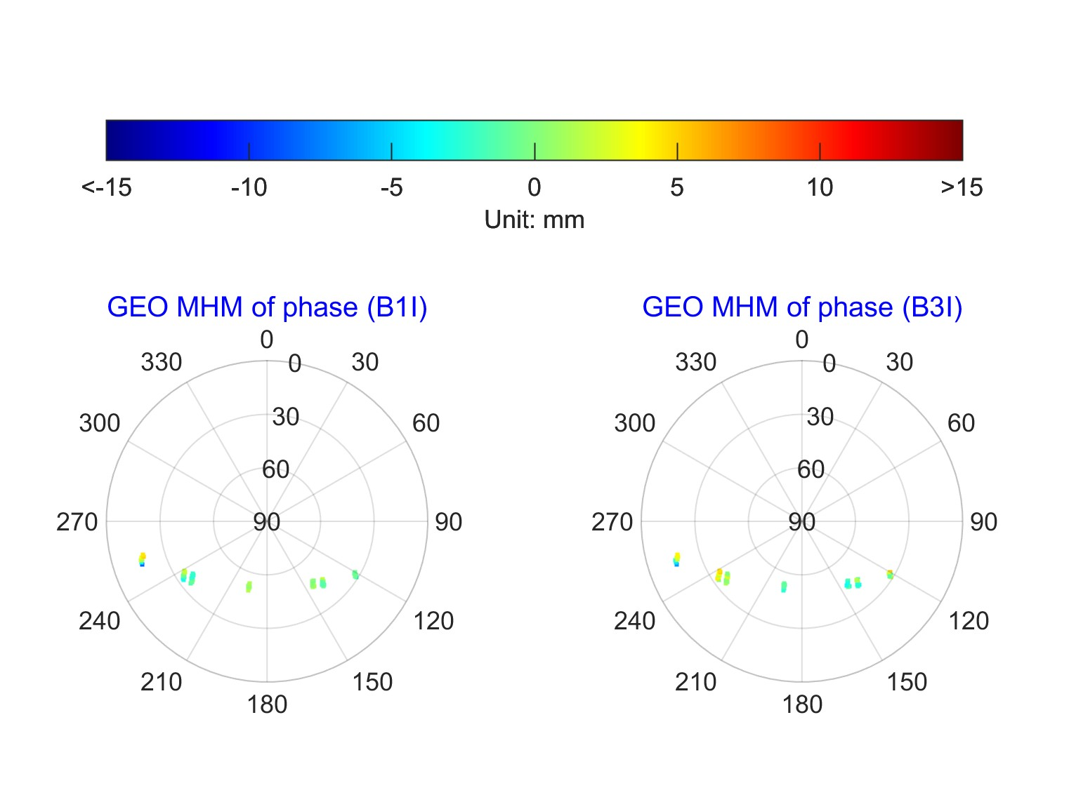

**Fig. 23** 2D sky plot of phase MHM for BDS GEO satellites

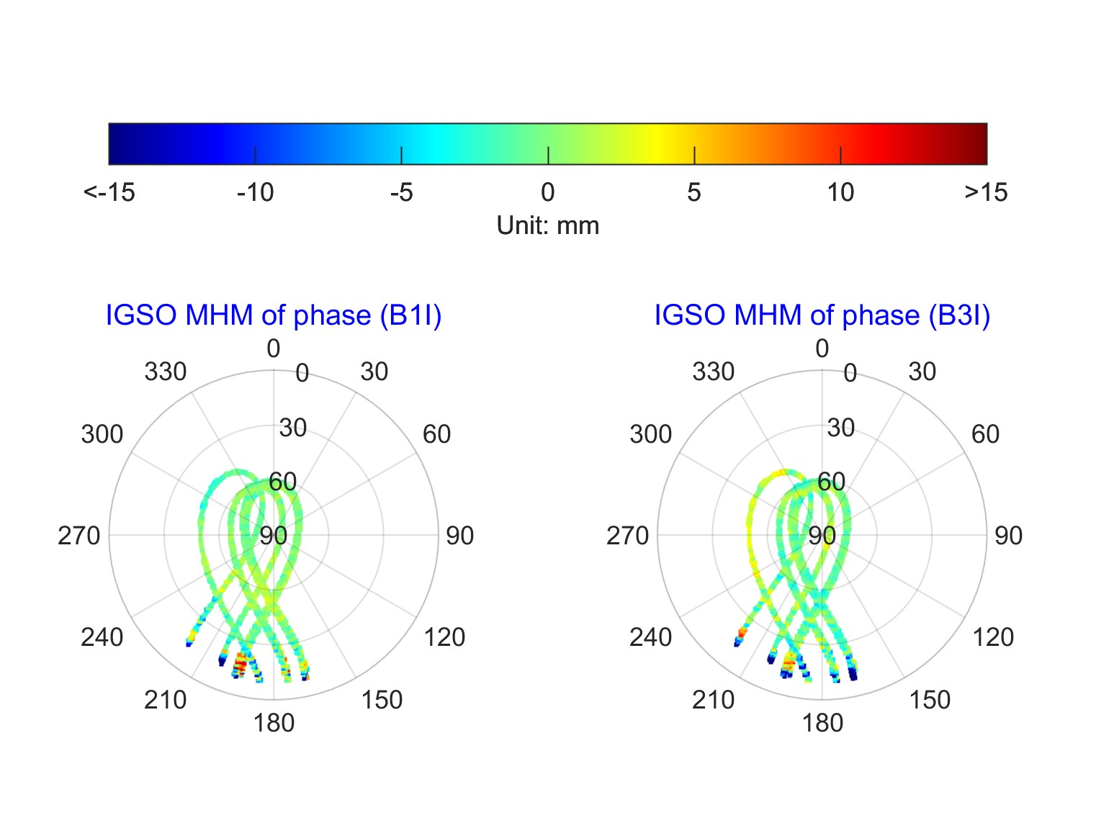

**Fig. 24** 2D sky plot of phase MHM for BDS IGSO satellites

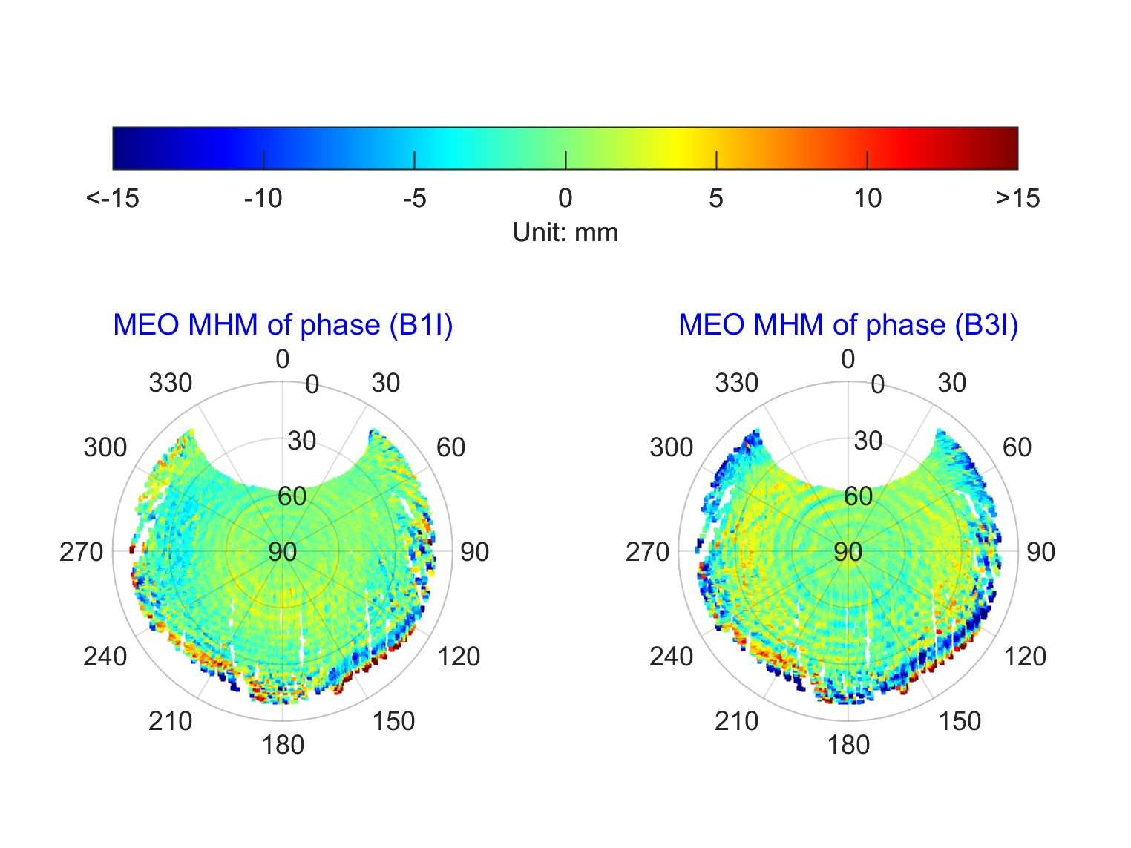

**Fig. 25** 2D sky plot of phase MHM for BDS MEO satellites

1. **FMHM**

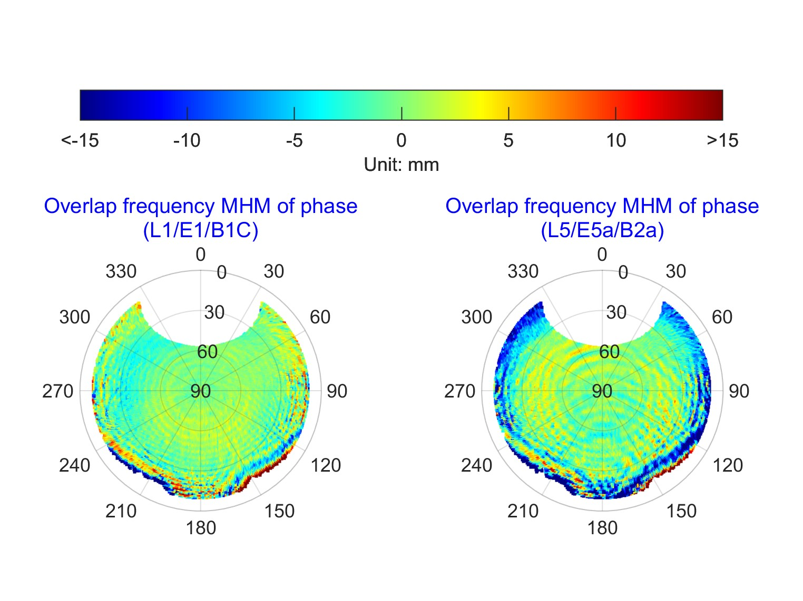

**Fig. 26** 2D sky plot of phase FMHM

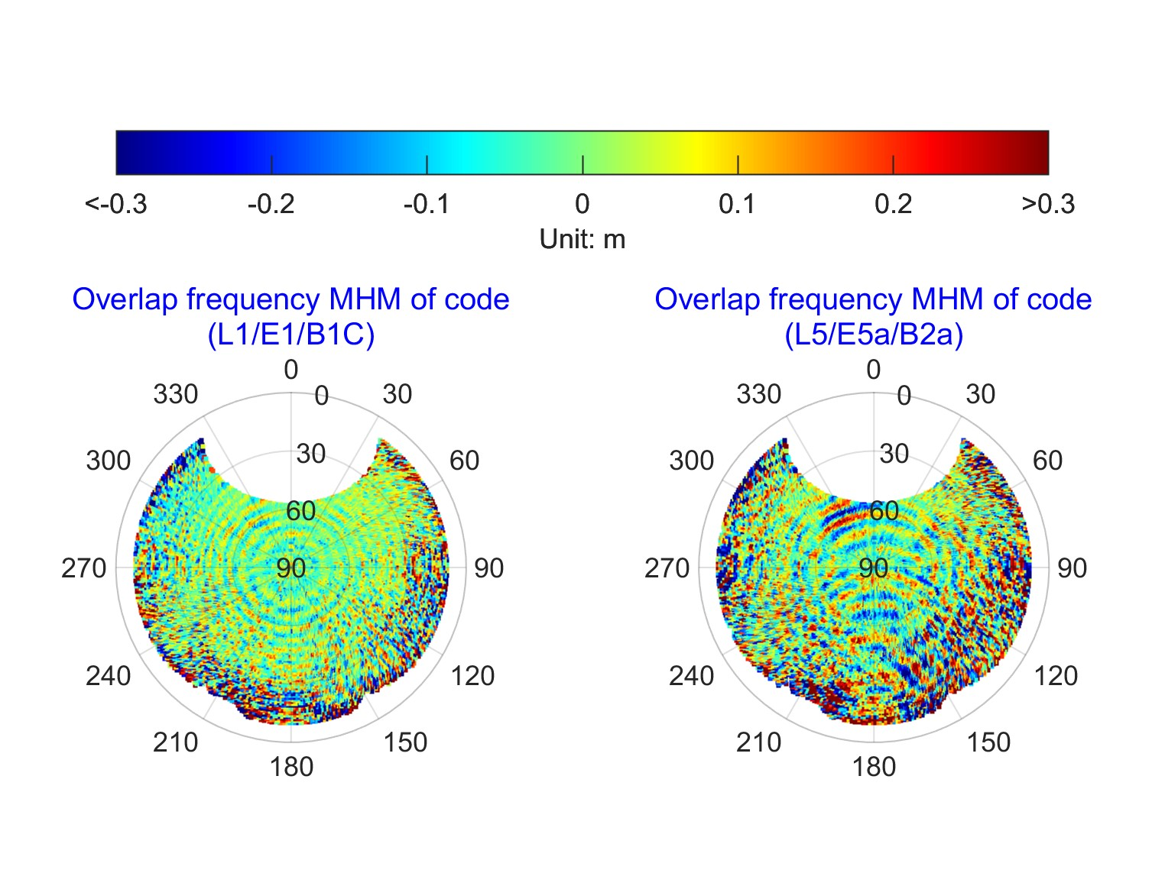

**Fig. 27** 2D sky plot of code FMHM

### 5.2.2 2D plane plot

1. **MHM**

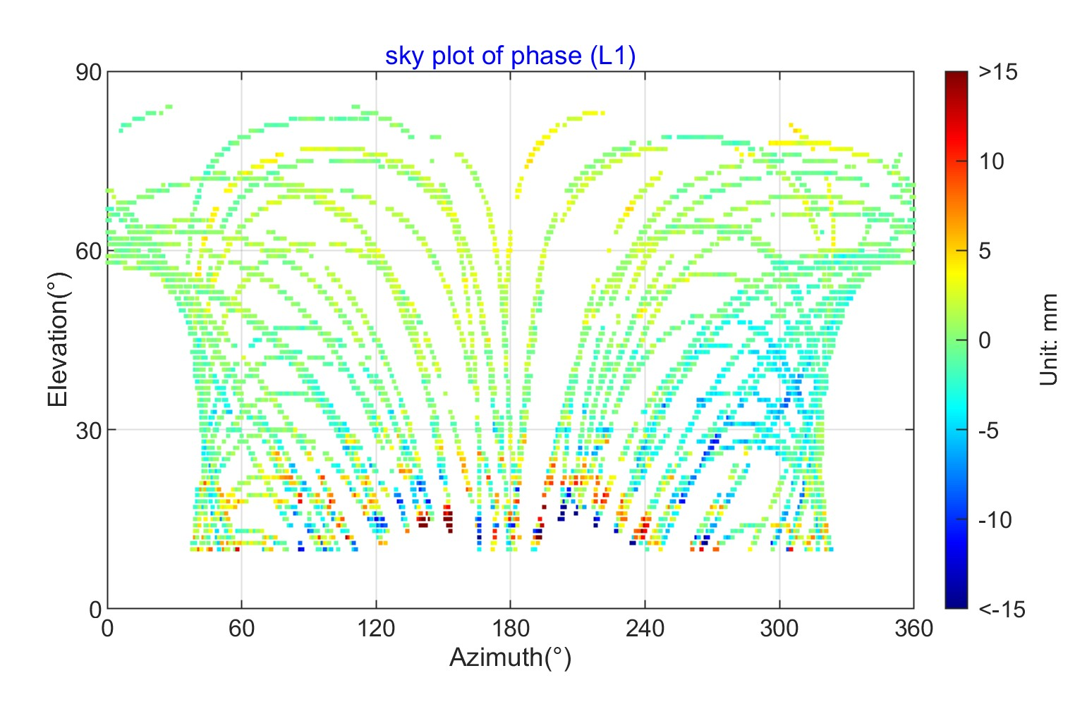

**Fig. 28** 2D plane plot of phase MHM for GPS

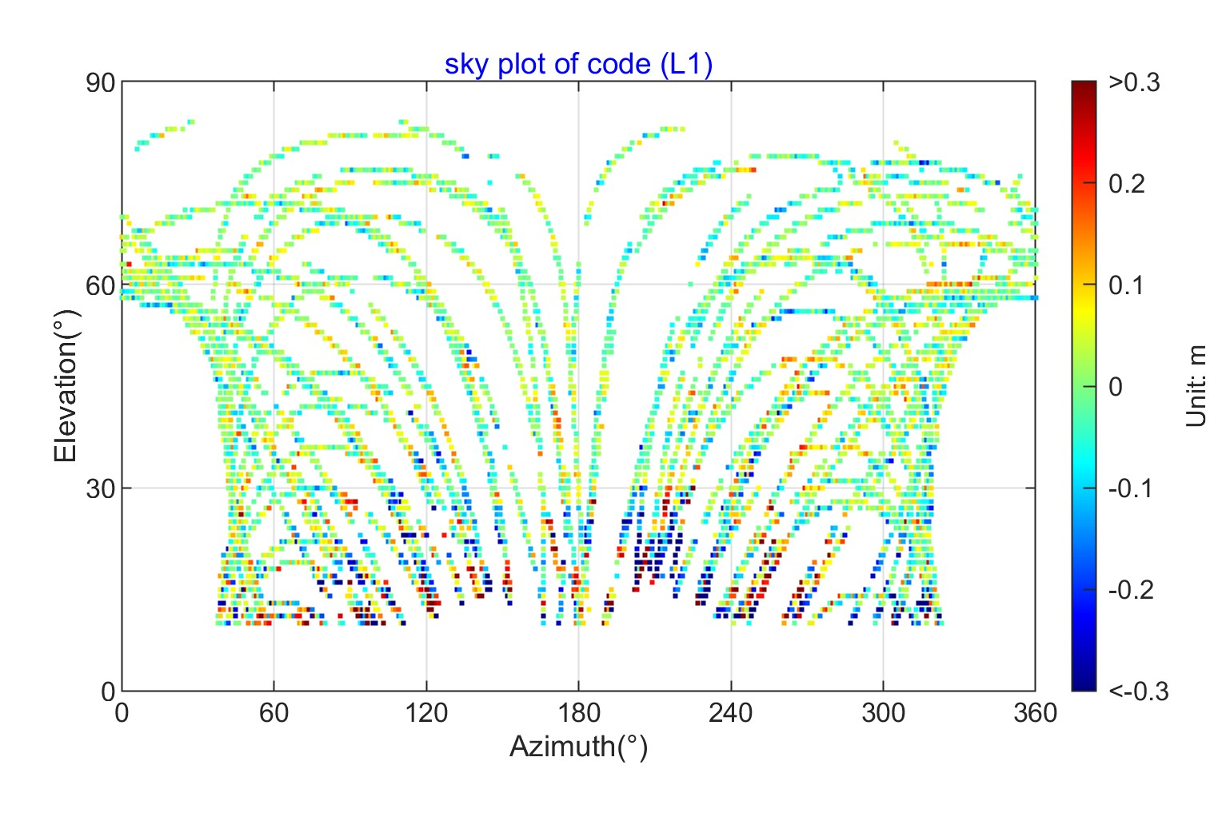

**Fig. 29** 2D plane plot of code MHM for GPS

1. **PMHM**

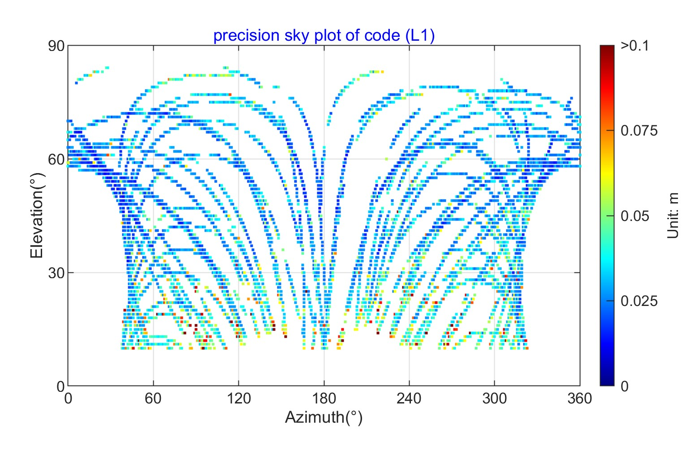

**Fig. 30** 2D plane plot of code PMHM for GPS

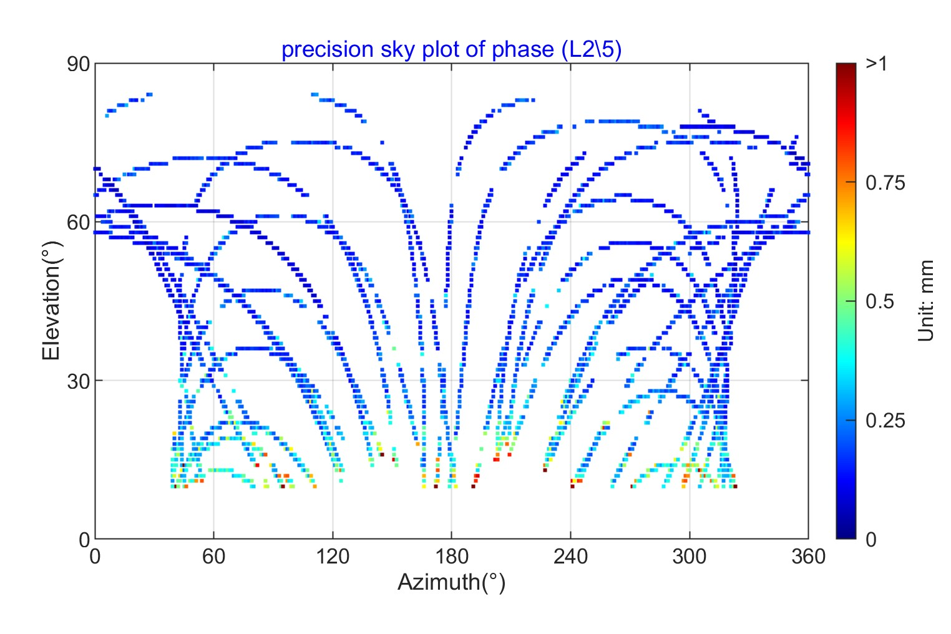

**Fig. 31** 2D plane plot of phase PMHM for GPS

1. **SMHM**

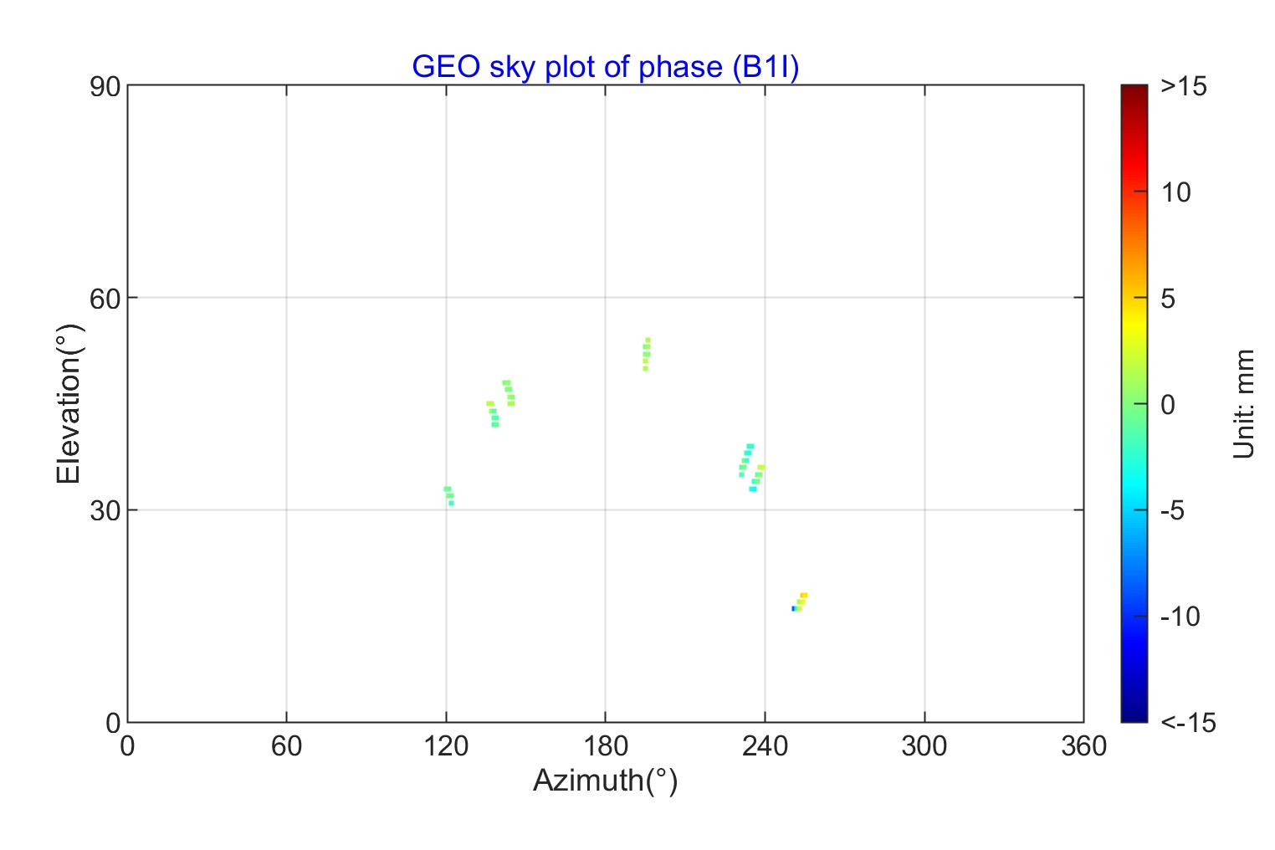

**Fig. 32** 2D plane plot of phase SMHM for BDS GEO satellites

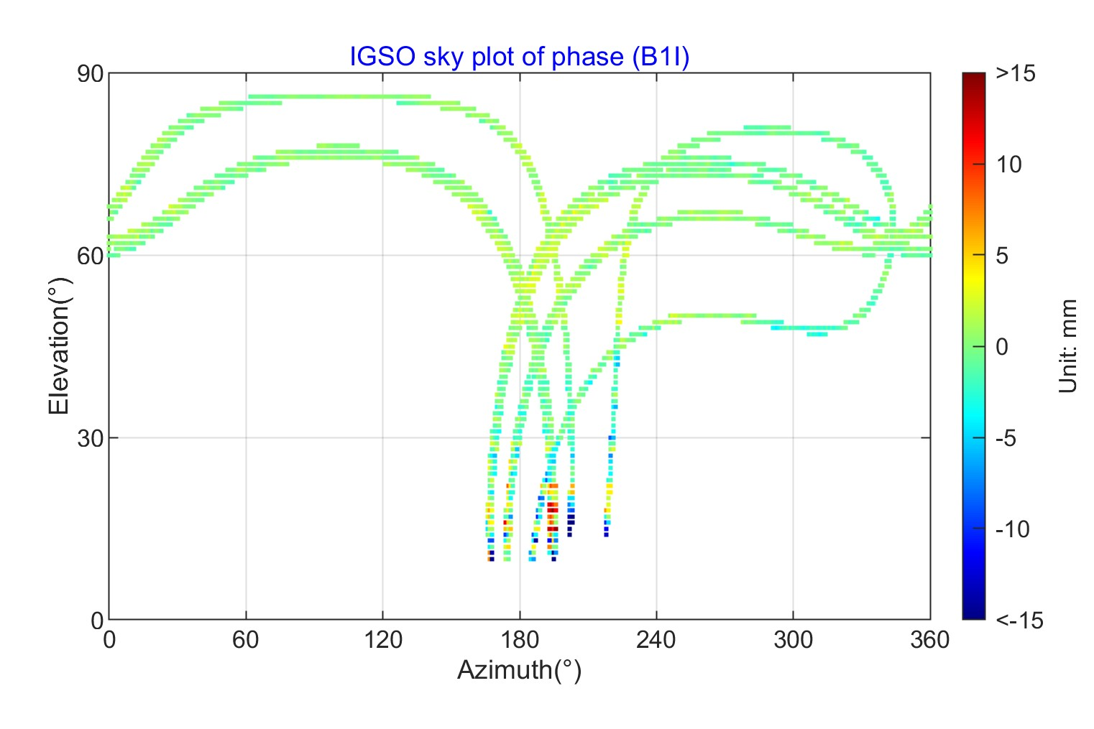

**Fig. 33** 2D plane plot of phase SMHM for BDS IGSO satellites

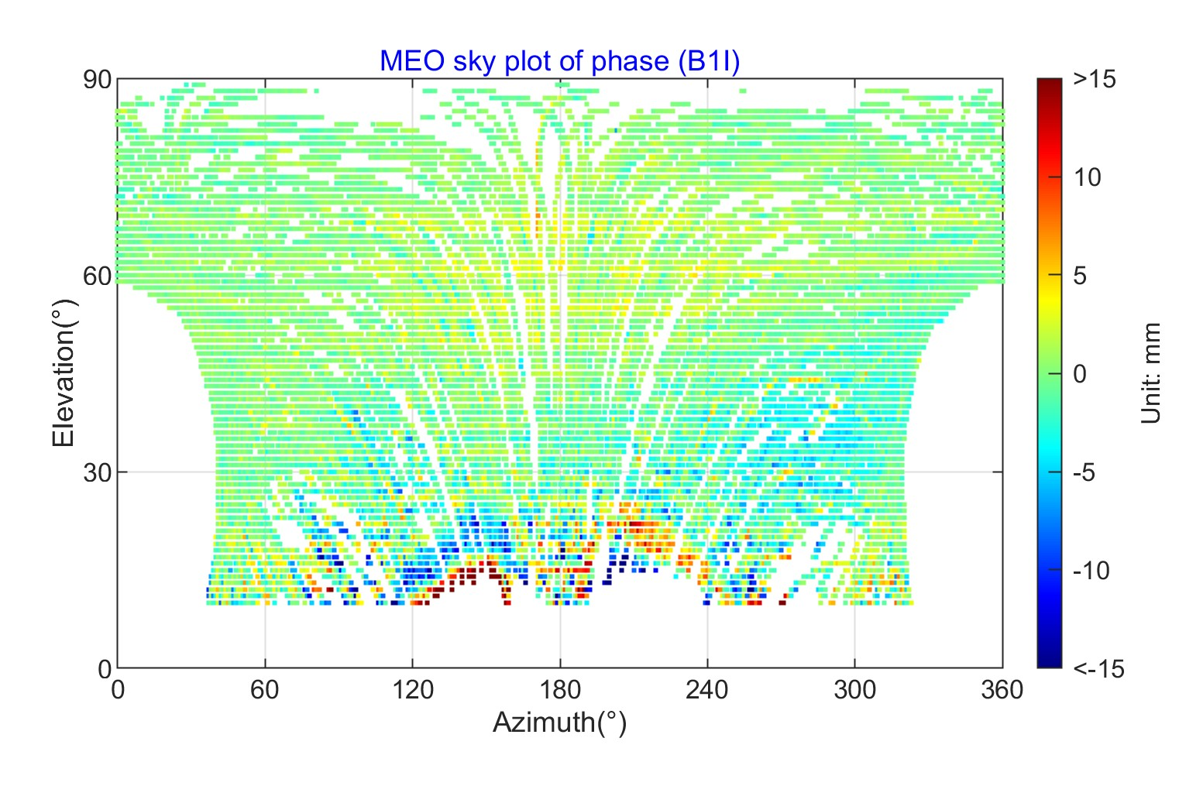

**Fig. 34** 2D plane plot of phase SMHM for BDS MEO satellites

1. **FMHM**

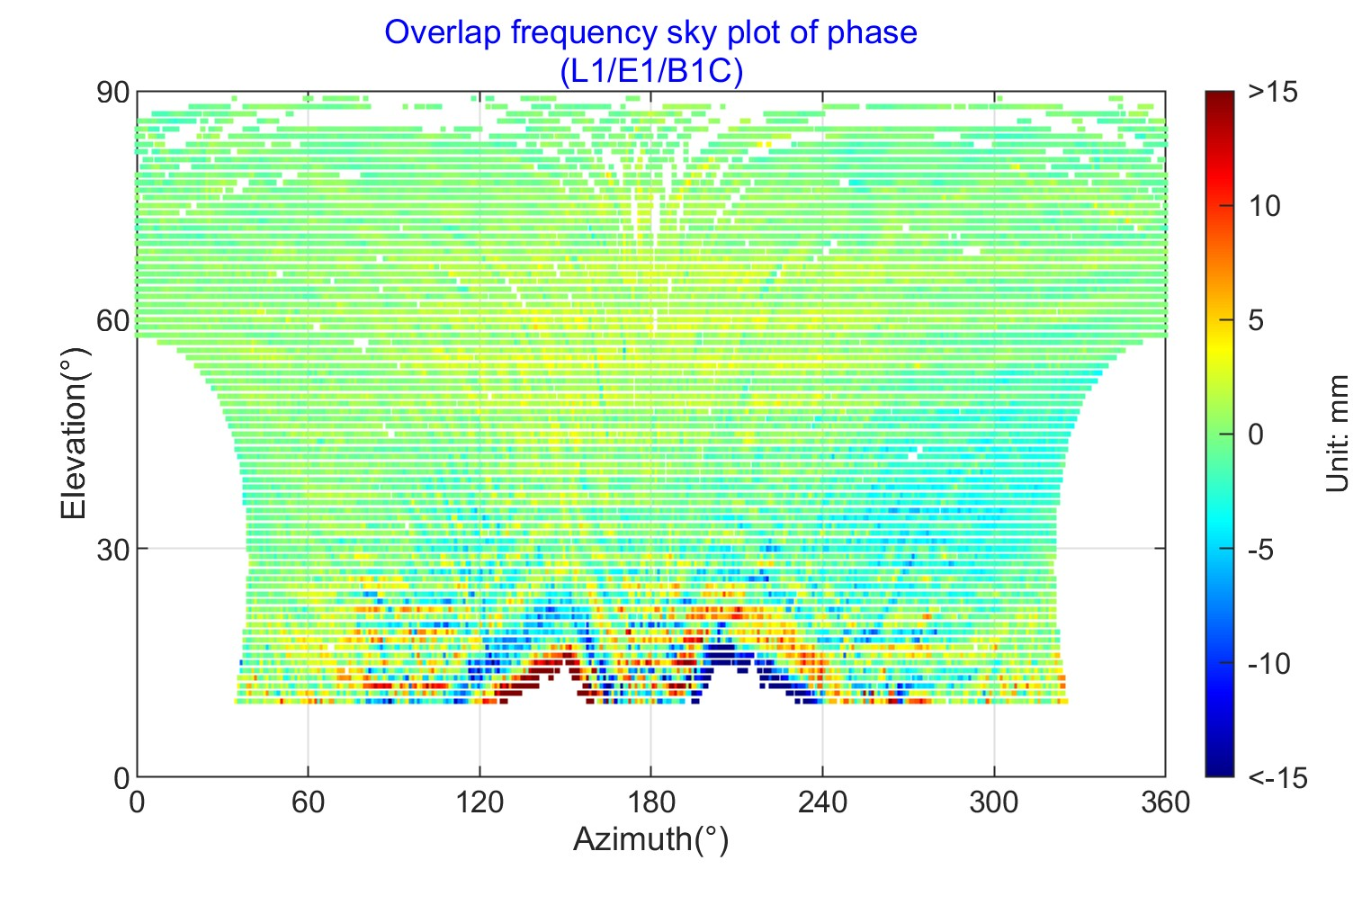

**Fig. 35** 2D plane plot of phase FMHM for L1/E1/B1C

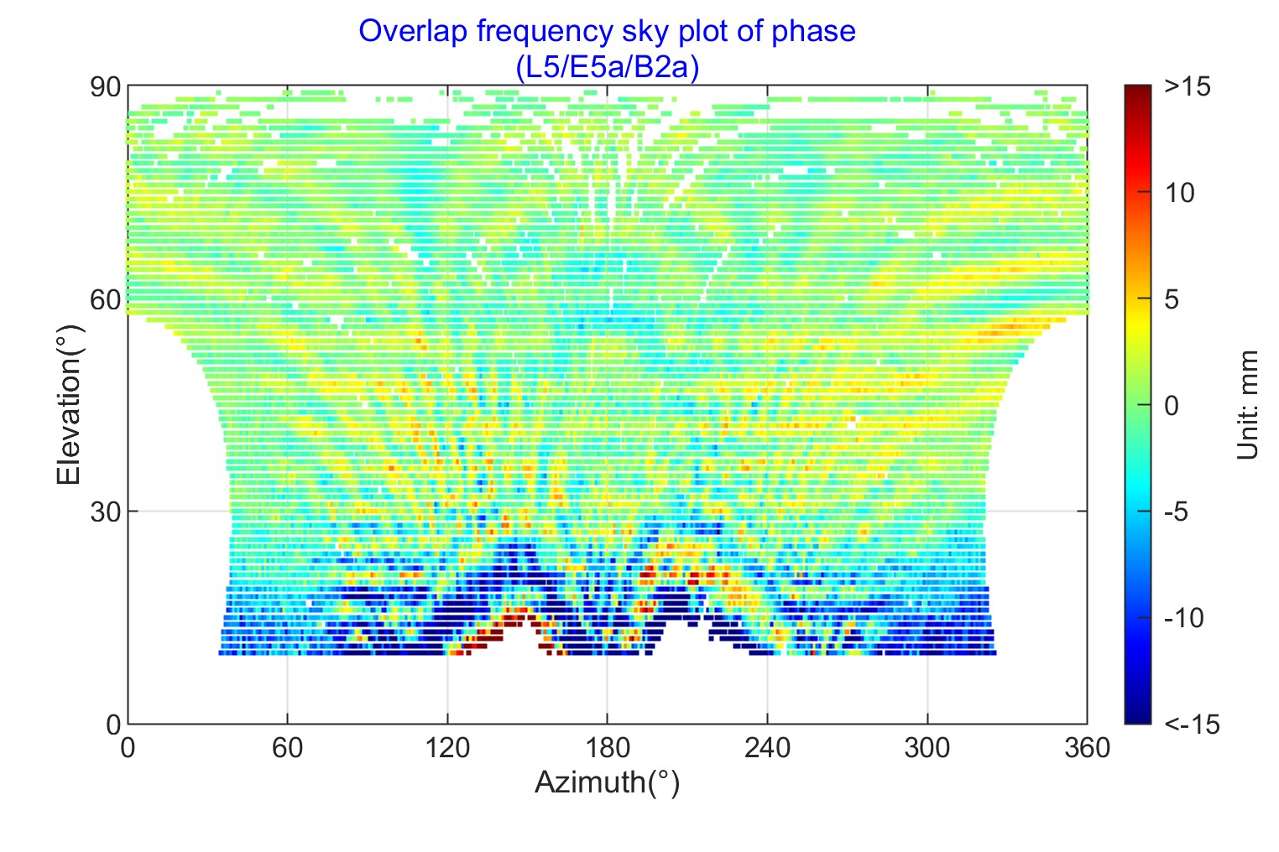

**Fig. 36** 2D plane plot of phase FMHM for L5/E5a/B2a

### 5.2.3 3D sky plot

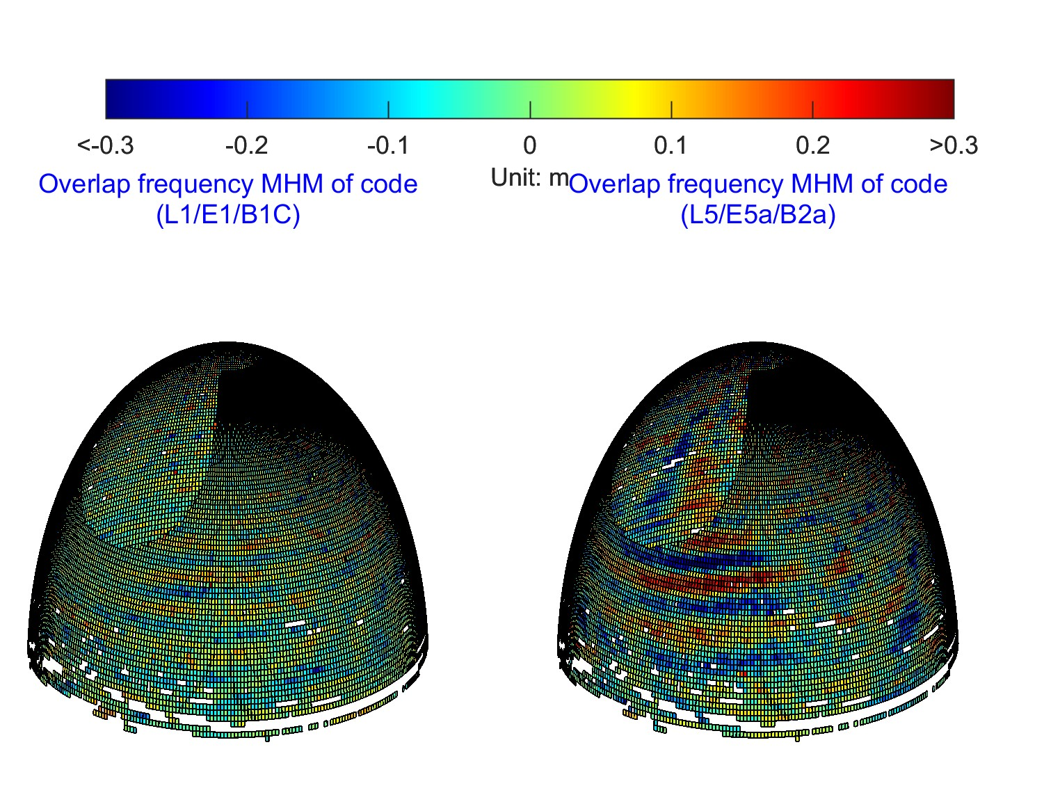

**Fig. 37** 3D sky plot of code FMHM

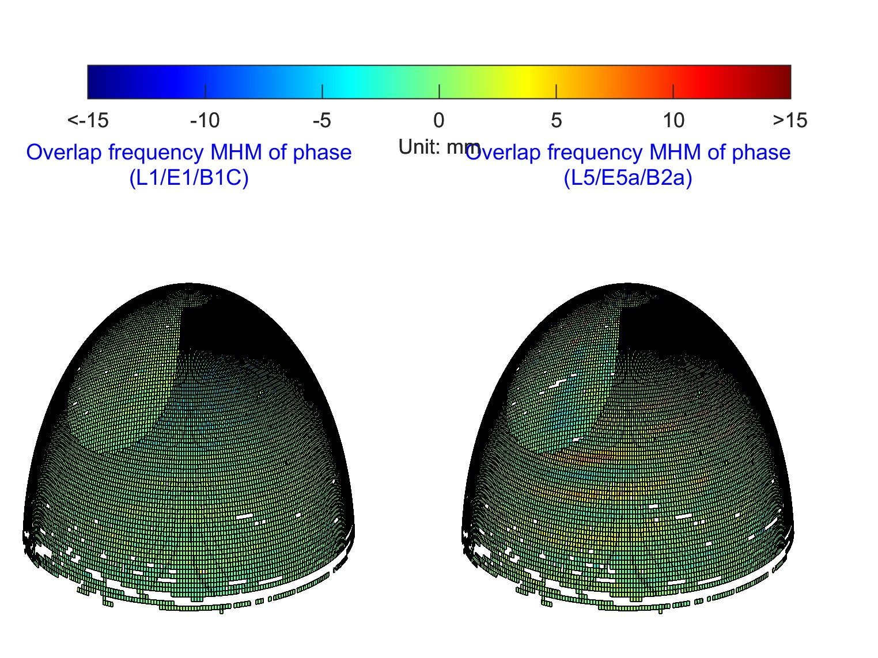

**Fig. 38** 3D sky plot of phase FMHM

## 5.3 Plotting of SF modeling

For the SF modeling part, the plotting of SF and SF_W models are supported. Some typical results are shown as following.

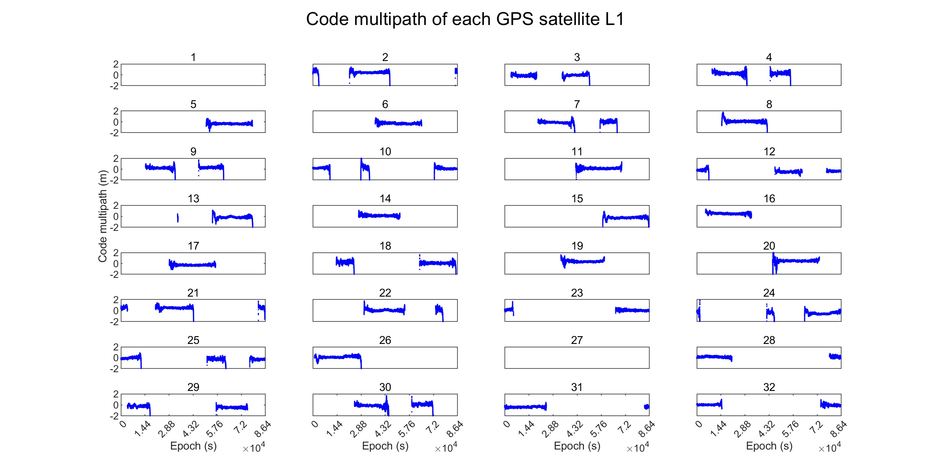

**Fig. 39** Time series plot of SF GPS L1 code multipath using SF model

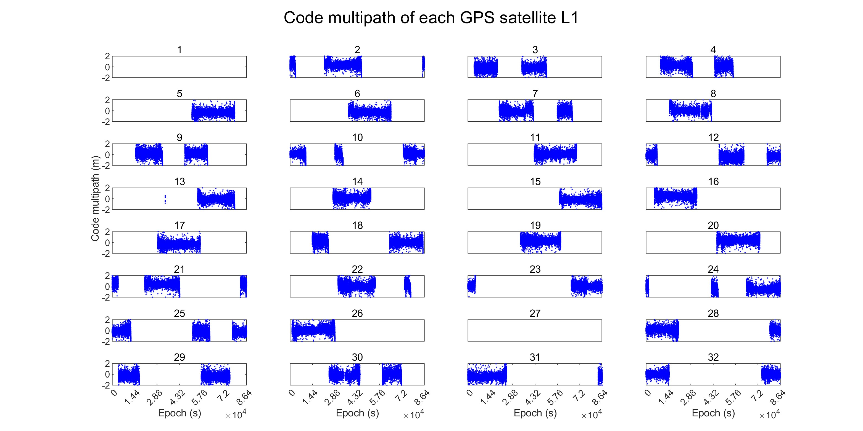

**Fig. 40** Time series plot of SF GPS L1 code multipath using SF_W model

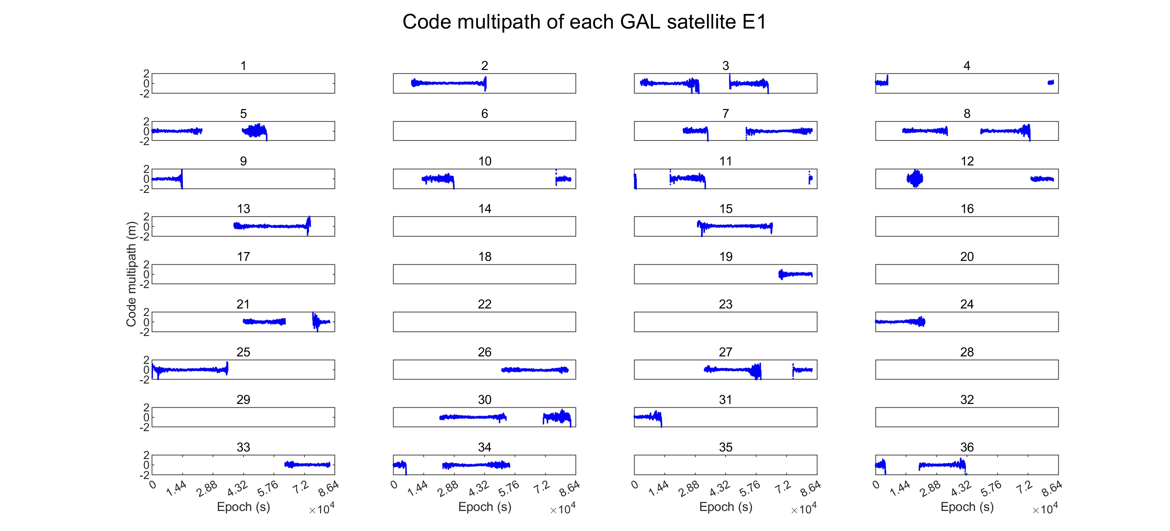

**Fig. 41** Time series plot of Galileo E1 code multipath using SF model

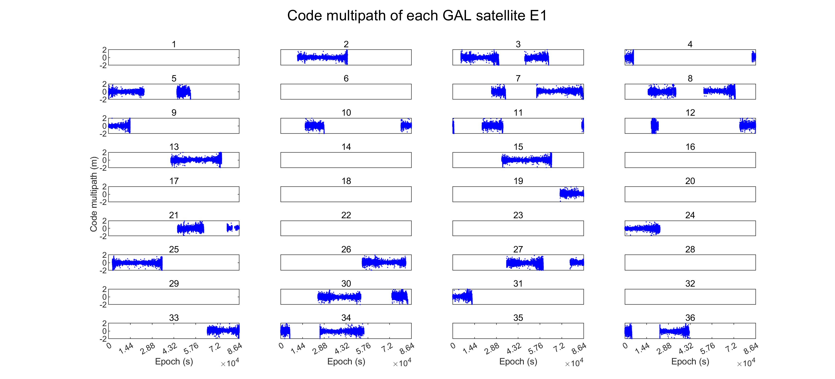

**Fig. 42** Time series plot of Galileo E1 code multipath using SF_W model

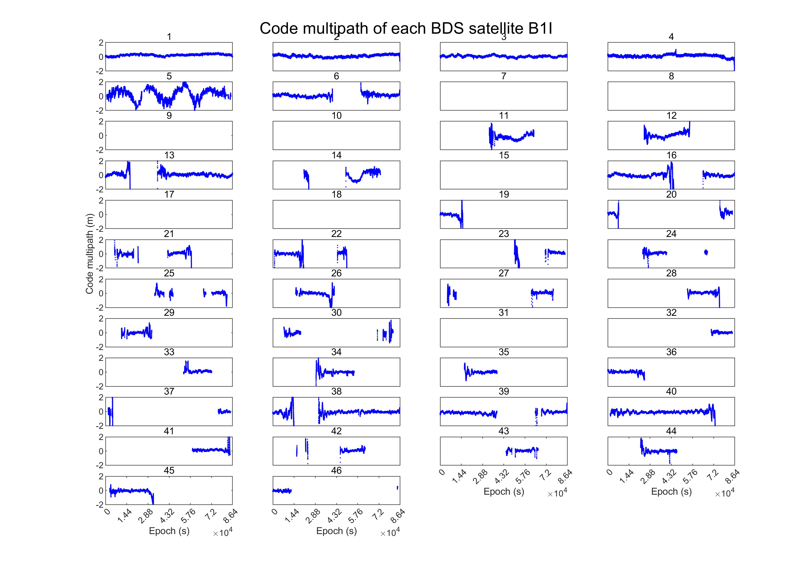

**Fig. 43** Time series plot of BDS B1I code multipath using SF model

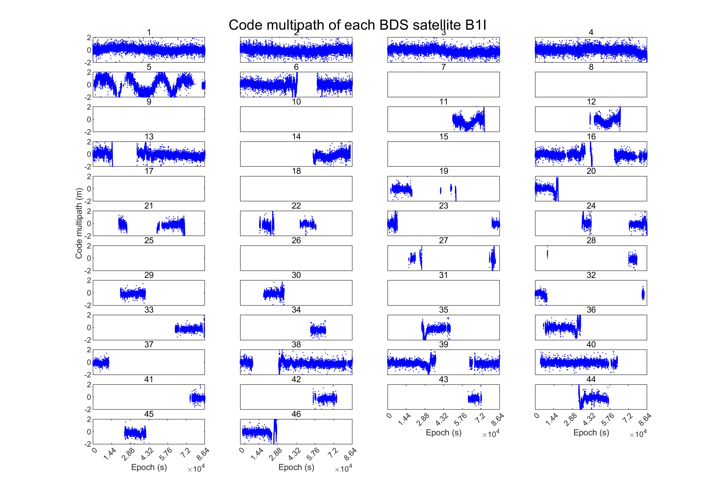

**Fig. 44** Time series plot of BDS B1I code multipath using SF_W model

# 6 Acknowledgement

The MAPS is developed based on MATLAB R2021a, and we are grateful to the MATLAB developers for their works. Part of the code of the MAPS is based on raPPPid software, and we are grateful to Glaner, MF, and Weber, R for their work. We are grateful to the RTKLIB software, on which our residual files are generated. In addition, we would like to thank the IGS and MGEX organizations, such as CODE, CAS, and WHU, for providing GNSS observations and related products.

# 7 Disclaimer

The experiment is carried out in MATLAB 2021a environment. With the update of the software, proper modifications of the code may be needed. Some bugs may still exist in the MAPS, comments and suggestions are welcome to send to the authors.

# 8 Contact us

GCC research group of dedicated developers earnestly seeks your valuable insights and suggestions to improve the MAPS. We welcome all users to share and exchange technical details, as well as provide improvement suggestions. Here are our contact details:

GitHub: https://github.com/GCCProTeam

Emails: zt.zhang@hotmail.com; navyyuan@yeah.net

# Reference

Anscombe FJ (1973) Graphs in statistical analysis. Am Stat 27(1):17-21.

Bock Y, Nikolaidis R, Jonge P, Bevis M (2000) Instantaneous geodetic positioning at medium distances with the global positioning system. J Geophys Res Solid Earth 105(B12):28223-28253.

Chayes F (1970) On deciding whether trend surfaces of progressively higher order are meaningful. Geol Soc Am Bull 81(4):1273-1278.

Cornell JA (1987) Factors that influence the value of the coefficient of determination in simple linear and nonlinear regression models. Phytopathology 77(1):63-70.

Glaner MF, Weber R (2023) An open-source software package for Precise Point Positioning: raPPPid. GPS Solut 27 (174).

Glaner MF (2022) Towards instantaneous PPP convergence using multiple GNSS signals. Technische Universität Wien, Vienna.

Koch K (1999) Parameter estimation and hypothesis testing in linear models. Springer, Berlin.

Lehmann E, Romano J (2006) Testing statistical hypotheses. Springer, Berlin.

Leick A, Rapoport L, Tatarnikov D (2015) GPS satellite surveying.Wiley, New York.

Lu R, Chen W, Dong D, Wang Z, Zhang C, Peng Y, Yu C (2021) Multipath mitigation in GNSS precise point positioning based on trend-surface analysis and multipath hemispherical map. GPS Solut 25(3):119.

Ragheb AE, Clarke PJ, Edwards SJ (2007) GPS sidereal filtering: coordinate- and carrier-phase- level strategies. J Geod 81(5):325–335.

Shen N, Chen L, Wang L, Lu X, Tao T, Yan J, Chen R (2020) Site-specific real-time GPS multipath mitigation based on coordinate time series window matching. GPS Solut 24:82.

Sobol MG (1991) Validation strategies for multiple regression analysis: using the coefficient of determination. Interfaces 21:106–120

Strode P, Groves P (2015) GNSS multipath detection using three-frequency signal-to-noise measurements. GPS Solut 20(3):399-412.

Wang Z, Chen W, Dong D, Wang M, Cai M, Yu C, Zheng Z, Liu M (2019) Multipath mitigation based on trend surface analysis applied to dual-antenna receiver with common clock. GPS Solut 23:104.

Yuan H, Zhang Z, He X, Zeng J, Wang H (2024) Improved Multipath Mitigation Using Multiple Trend-Surface Hemispherical Map in GNSS Precise Point Positioning. IEEE Sens. J 24(8):13095-13103.

Zhang Z, Dong Y, Wen Y, Luo Y (2023) Modeling, refinement and evaluation of multipath mitigation based on the hemispherical map in BDS2/BDS3 relative precise positioning. Measurement 213.

Zhang Z, Dong Y, Wen Y, Yuan H, Li B (2024) Robust Pseudorange and Carrier Phase Multipath Mitigation With Hemispherical Map Considering the Uncertainty. IEEE Sens. J 24(7):10832-10840.

Zhang Z, Li B, Gao Y, Shen Y (2019) Real-time carrier phase multipath detection based on dual-frequencyC/N0 data. GPS solut 23:7.

Zhang Z, Yuan H, Li B, He X, Gao S (2021) Feasibility of easy‑to‑implement methods to analyze systematic errors of multipath, differential code bias, and inter‑system bias for low‑cost receivers. GPS Solut 25:116.